

METU EE 400 SUMMER PRACTICE REPORT

**MEHMET ERALP KÖSE**

ASELSAN TEKNOKENT YERLEŞKESİ

**From**: 17.07.2017

**To**: 16.08.2017

Supervisor: Fehmi KAYA

**TABLE OF CONTENTS**

|  |  |
| --- | --- |
| 1. **DESCRIPTION OF THE COMPANY …………………………………………** | 3 |
| * Organizational Structure of The Company …………………………………… | 3 |
| * Brief History of The Company ……………………………………………….. | 4 |
| 1. **INTRODUCTION ……………………………………………………………….** | 4 |
| 1. **REPORT ………………………………………………………………………….** | 5 |
| * Buck Converter Topology …………………………………………………….. | 5 |
| 1. Power MOSFET Selection ………………………….……………………. | 7 |
| 1. Inductor Selectıon ……………….………………………………………… | 7 |
| 1. Capacitor Selection ………………………………….…………………….. | 8 |
| 1. Analyses By Simulations ………………………………………………….. | 8 |
| 1. Practical Analyses and Tests ……………………………………………... | 18 |
| E.1.) Analysis at 150 kHz Operational Frequency ……………….……... | 18 |
| E.1.1.) Efficiency Analysis …………………………………………… | 18 |
| E.1.2.) Voltage Ripple Analysis …………………………………….. | 20 |
| E.1.3.) Spectral Analysis ……………………………………………… | 25 |
| E.2.) 225 kHz Operational Frequency ……………………………………... | 27 |
| E.2.1.) Efficiency Analysis ……………………………………………. | 27 |
| E.2.2.) Ripple Voltage Analysis ………………………………………. | 29 |
| E.2.3.) Spectral Analysis ……………………………………………… | 31 |
| E.2.4.) Line and Load Regulations ……………………………………. | 35 |
| E.3.) Frequency Sweep Analysis When Chroma Varying Load is Used …… | 36 |
| 1. **CONCLUSION …………………………………………………………………..** | 38 |
| 1. **REFERENCES …………………………………………………………………..** | 39 |
| 1. **APPENDIX ……………………………………………………………………….** | 39 |

1. **DESCRIPTION OF THE COMPANY**

ASELSAN was established 1975 in order to provide Turkish army forces with hundred percent independently equipped. Particularly, communication and coordination problems have been aimed to solve initially. Now, ASELSAN is one of the most significant defense industry company in the world. Since the establishment, ASELSAN and the employees works for developing the latest technology for the army and consumers. ASELSAN employed nearly 5000 personal and 70 percent of them are engineers.

* **Organizational Structure of The Company**

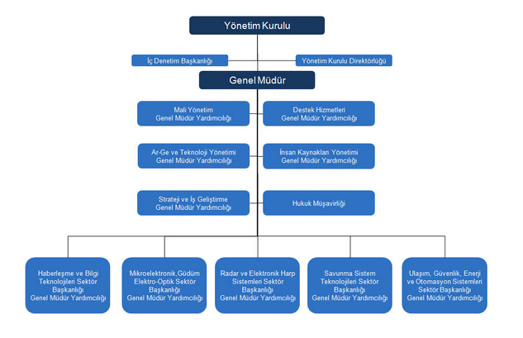

Figure 1: Organizational Structure of the Company

ASELSAN have 5 sub- departments which are HBT, MGEO, REHİS, SST and UGES. SST and UGES is located in Macunköy, Ankara. MGEO is located in Akyurt, Ankara. REHİS is located in Gölbaşı, Ankara. HBT is located in Macunköy and METU Teknokent. I have completed my Summer Practice at METU Teknokent facility working in HBT- Military Communication Units, Electronical Design and Power Sources Subgroup. In this subgroup, power source system according to the specifications of that communication device is designed and manage the developed system accurately. Also, research and development, test, control and maintenance activities are conducted in this department.

* **Brief History of The Company**

ASELSAN was established in 1975. The first walky talkies called Sahra was produced in 1980 and they delivered to Turkish Army. Company made its the first export in 1980. . Then ASELSAN involved in a project with four NATO countries in order to manufacture Stinger missiles and started production of thick film hybrid circuits in 1987. In 1989 it carried out its first technology transfer to Pakistan and IPO was first made in 1990. After this time, ASELSAN has paced and enlarged its studies and it reached global rate. Nowadays, ASELSAN continues its studies and continues to produce latest technology.

1. **INTRODUCTION**

I have completed my summer practice in ASELSAN from 17 July to 16 August. In this period, practical engineering applications have been observed and some experiments, tests have been done. Buck converter has been done and a lot of analyses and tests have been done by me. The aim was that output value should be 5V and 10 A from 12 V input value. Firstly, main converter topologies have been researched such as Linear Regulators, Buck converters and Boost converters. However, mainly, I focused on Buck converters. At that time, some sources have been used. The book called ‘Switching Power Supply Design by Abraham I. Pressman’ has been used and some PDF sources have been used. After that, some datasheets have been examined. LTC1775 integrated circuit has been used and its datasheet has been examined. Also, some inductors, capacitors and MOSFETs have been examined and compared in order to achieve optimum design. After literature research, simulations have been done. Different variations have been tried by changing resistors, inductors, capacitors and switching MOSFETs. Then, I have worked on PCB card which had been given to me from ASELSAN. Some modifications have been done as my design. After this process, efficiency comparisons have been done for varying conditions and switching ripple analyses, spectral analyses etc. have been done as will be explained.

1. **REPORT**

In this summer practice, buck converter whose output is 5V, 10A has been designed. Throughout this process, optimum efficiency and ripple have been tried to obtained. Theoretical and practical analyses have been done in order to optimum design.

* **Buck Converter Topology**

Buck converters can produce lower average output voltage from higher input voltage. Size, efficiency, cost, temperature, accuracy, and transient response are crucial issues while select converters. Synchronous and nonsynchronous buck converters are used and efficiency varies depends on the conditions.

Topology 1: Nonsynchronous Buck Converter

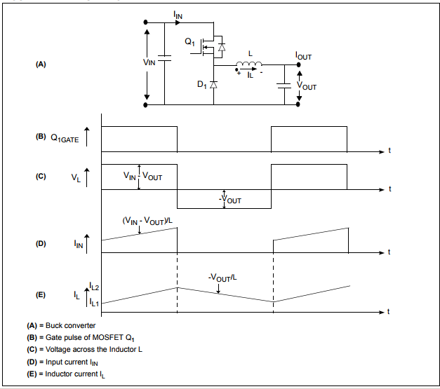

In nonsynchronous buck converter, Q1 behaves as switch. At steady state, when Q1 is on with a period TON, Vin provides energy to output as well as the inductor. During the TON period, the inductor current flows through the switch and the difference of voltages between Vin and Vout is applied to the inductor in the forward direction, as shown in Topology 1 (C). Therefore, the inductor current IL rises linearly from its present value IL1 to IL2, as shown in Topology 1 (E). When Q1 is off with a period TOFF, the inductor current continues to flow in the same direction, because the stored energy within the inductor continues to supply the load current. The diode D1 completes the inductor current path during TOFF. During this TOFF period, the output voltage Vout is applied across the inductor in the reverse direction, as shown in Topology 1 (C). Therefore, the inductor current decreases from its present value IL2 to IL1, as shown in Topology 1 (E) [1].

In addition Duty cycle is crucial for Vout/Vin rate.

$$Vout=Duty Cycle*Vin$$

$$Duty Cycle=\frac{Ton}{Switching Period}$$

Topology 2: Nonsynchronous Buck Converter

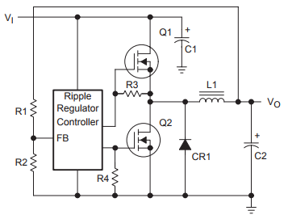

When output voltage falls below the regulation level, Q1 MOSFET is turned on and Q2 MOSFET is turned off at the synchronous buck converter so inductor is fed and output voltage can achieve regulation level. On the contrary, when output voltage is higher than regulation level, Q1 MOSFET is turned off and Q2 MOSTEF is turned on so inductor can deliver the load through Q2. This maintains continuous power delivery during the on and off states of Q1. Also, Q1 and Q2 cannot be open simultaneously[4].

LTC 1775 integrated circuit, which is used in my design, is also behaves as a synchronous buck converter.

1. **Power MOSFET Selection**

From the Datasheet,

$Rds\left(on\right)=\frac{240mV}{\left(ρT\right)*Imax}$ (1)

and 10 A output current is necessary so if (ρT) value is considered as 1.3 at 60oC, RDS(max) is 18 mΩ.

1. **Inductor Selection**

From the Datasheet,

$ΔIL=\left(\frac{Vout}{f*L}\right)*(1-\frac{Vout}{Vin})$ (2)

$L≥\left(\frac{Vout}{f*ΔILmax}\right)(1-\frac{Vout}{Vinmax})$ (3)

Also, ΔILmax is 40% of Imax which is 10 A (from datasheet). Therefore, ΔILmax is 4A.

If SYNC pin is open or ground, operational frequency is 150 kHz from datasheet so

$$L≥\left(\frac{5V}{150kHz*4A}\right)\left(1-\frac{5V}{12V}\right)=4.86 uH$$

Furthermore,

$Ilimit=\frac{300mV}{Rds\left(on\right)*\left(ρT\right)}-\frac{1}{2}*ΔIL$ (4)

1. **Capacitor Selection**

From Datasheet,

$$ΔVout≤ΔIL(ESR+\frac{1}{8*f*Cout})$$

ΔVout is related to ripple voltage and ripple voltage is tried to decrease by changing Cout value. Also I connect capacitors parallel in order to decrease ESR (Equivalent Series Resistance) value.

1. **Analyses By Simulations**

After this process, Simulations were used and the results were analyzed. By using LT Spice, a lot of options were tried by varying capacitors. Inductors, MOSFETs and results were compared. Initially, STL23NS3LLH7 MOSFET which has 3.7mΩ RDS(ON) resistance and 13.7 nC gate charge was used. Ilimit= 79 A from equation (4) in this condition so it is applicable [1].

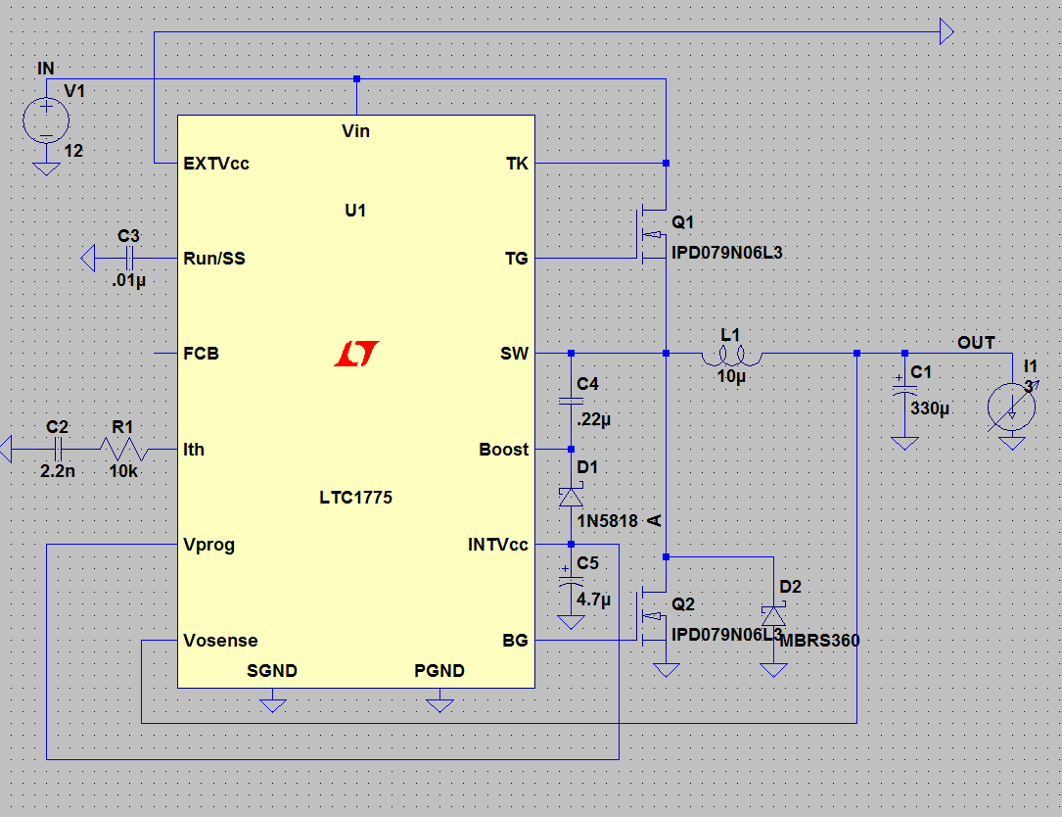

Figure 2. Overall Schematic on LT Spice

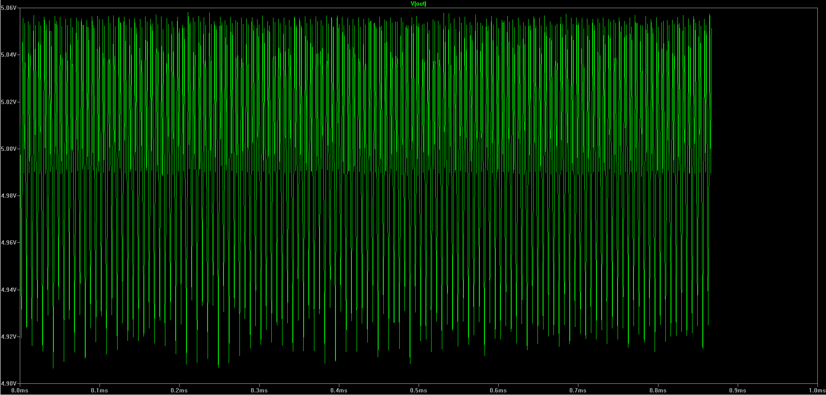

Figure 3. Output Voltage of the Buck Converter

A lot of variations were tied by using ‘.step param’ command at LT Spice. By using **‘.step param L list 5u 10u 15u’** this inductor values were tried simultaneously. Similarly by using **‘.step param C list 300u 400u 500u’** this capacitor values were tried and 9 different conditions were tried thank to this function as shown in Figure 5 and Figure 6.

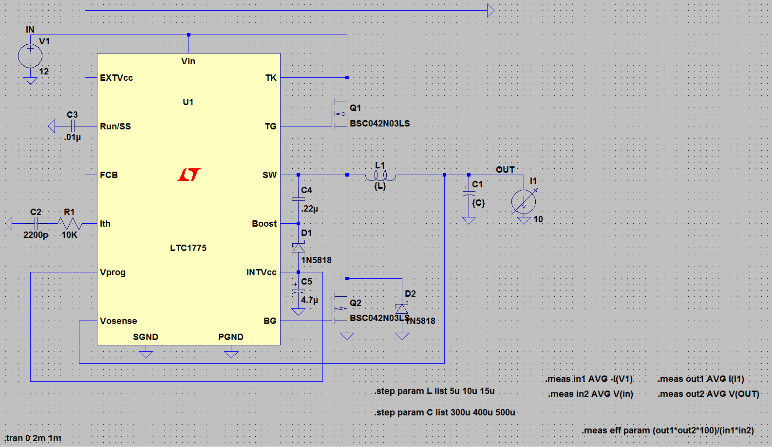

Figure 4. Overall Schematic with varying inductor and capacitance function

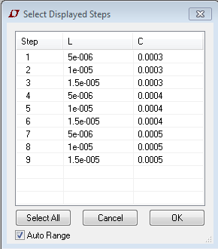

Figure 5. Varying Conditions table

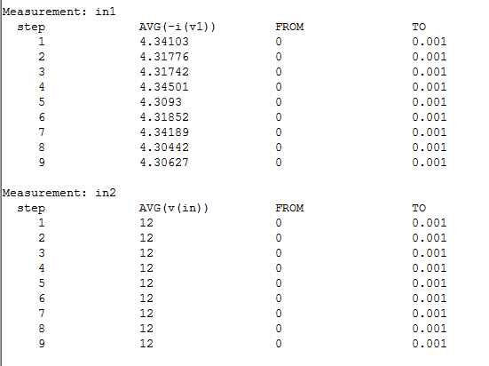

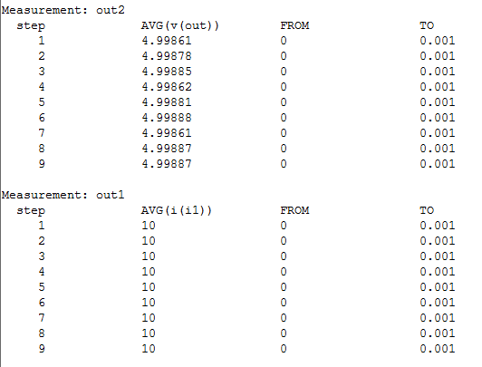

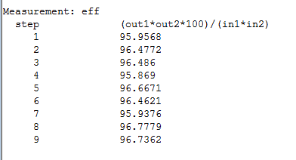

Figure 6. Results of Simulation

in1: Input Current

in2: Input Voltage

out1: Output Voltage

out2: Output Current

9 values are analyzed respectively as Figure 5.

After that ripples are examined respectively.

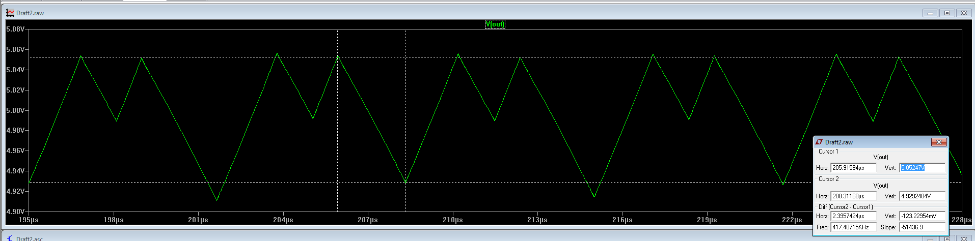

Figure 7. Ripple for 15uH-300uF

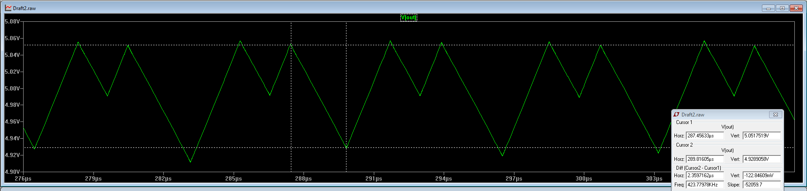

Figure 8. Ripple for 25uH-500uF

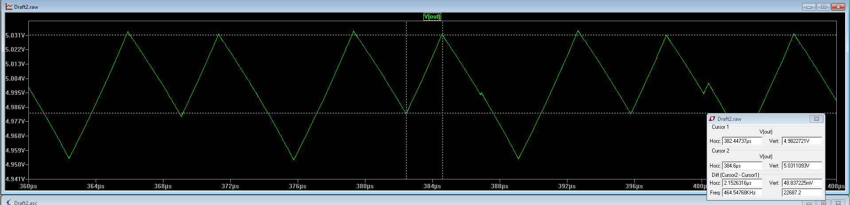

Figure 9. Ripple for 315uH-300uF

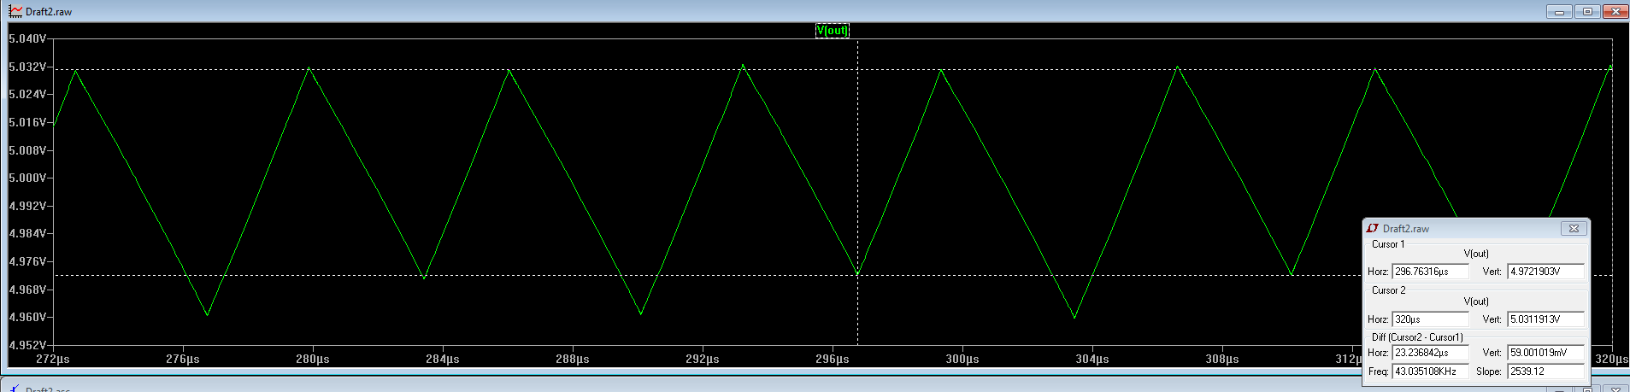

Figure 10. Ripple for 415uH-500uF

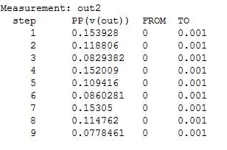

Figure 11. Ripples for varying conditions

Secondly, CSD18563Q5A switching MOSTEF which has 8.6mΩ RDS(ON) resistance and 15 nC gate charge is used and test have done again. Firstly, simulations are set and results are compared with STL23NS3LLH7 MOSFET. Ilimit= 26 A from equation (4) in this condition so it is applicable.

Efficiencies and ripple voltages are compared for varying R and C values as shown in Figure 14, Figure 15, Figure 16.

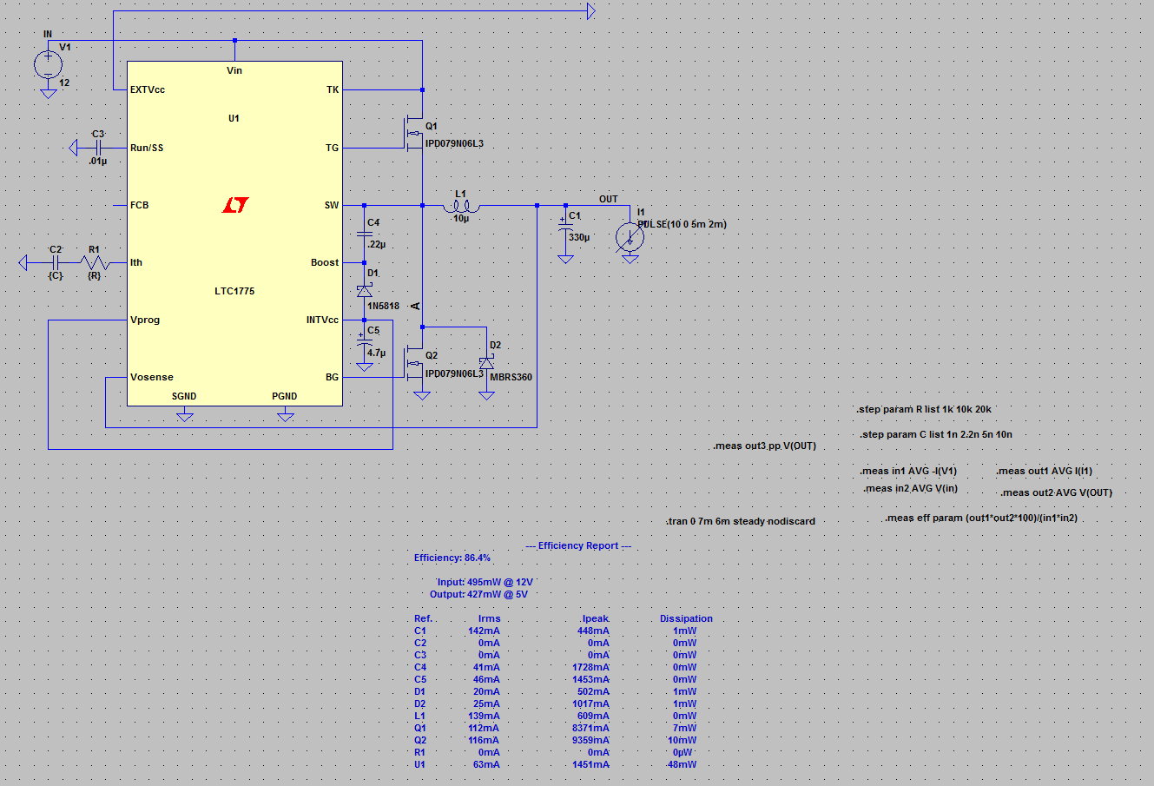

Figure 12. Overall Schematic for Varying R and C values by using CSD18563Q5A switching MOSTEF

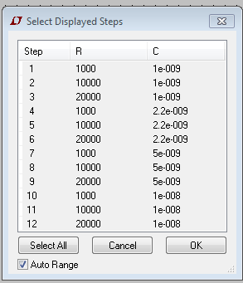

Figure 13. Varying Conditions table

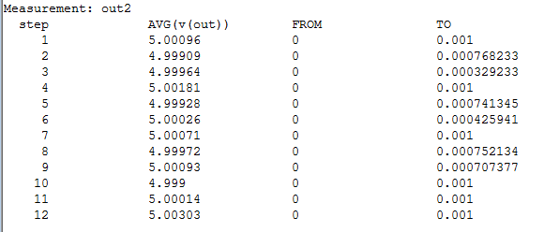

Figure 14. Output Voltages for varying R and C values

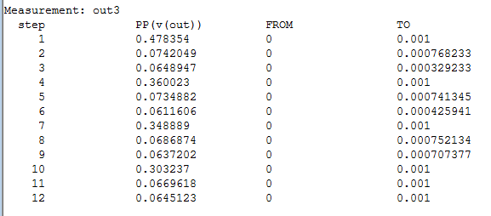

Figure 15. Ripple Voltages for varying R and C values

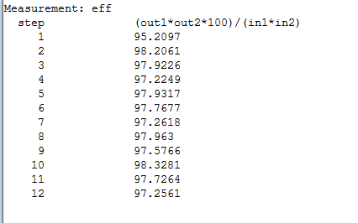

Figure 16. Efficiencies for varying R and C values

When Figure 6 and Figure 16 are compared, it is obvious that CSD18563Q5A switching MOSTEF works more efficiently. When efficiency and ripple are considered, 2.2nC capacitor and 10kΩ resistance have been chosen.

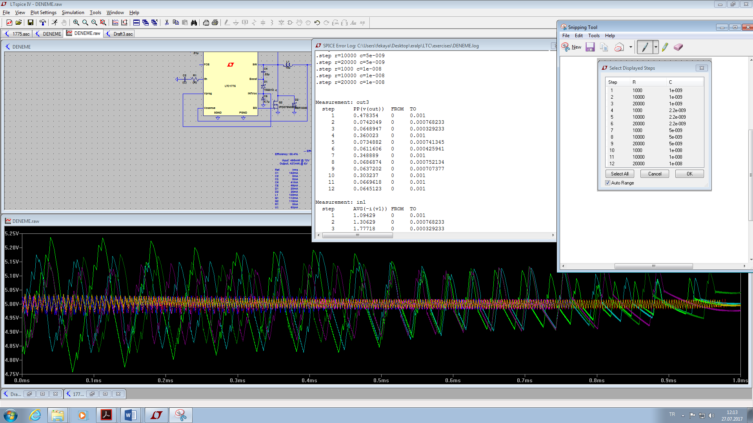

Figure 17. Simulation Result which Shows Ripple Voltages for varying R and C Values

After that ripple voltages and efficiencies are calculated on LT Spice for varying load current.

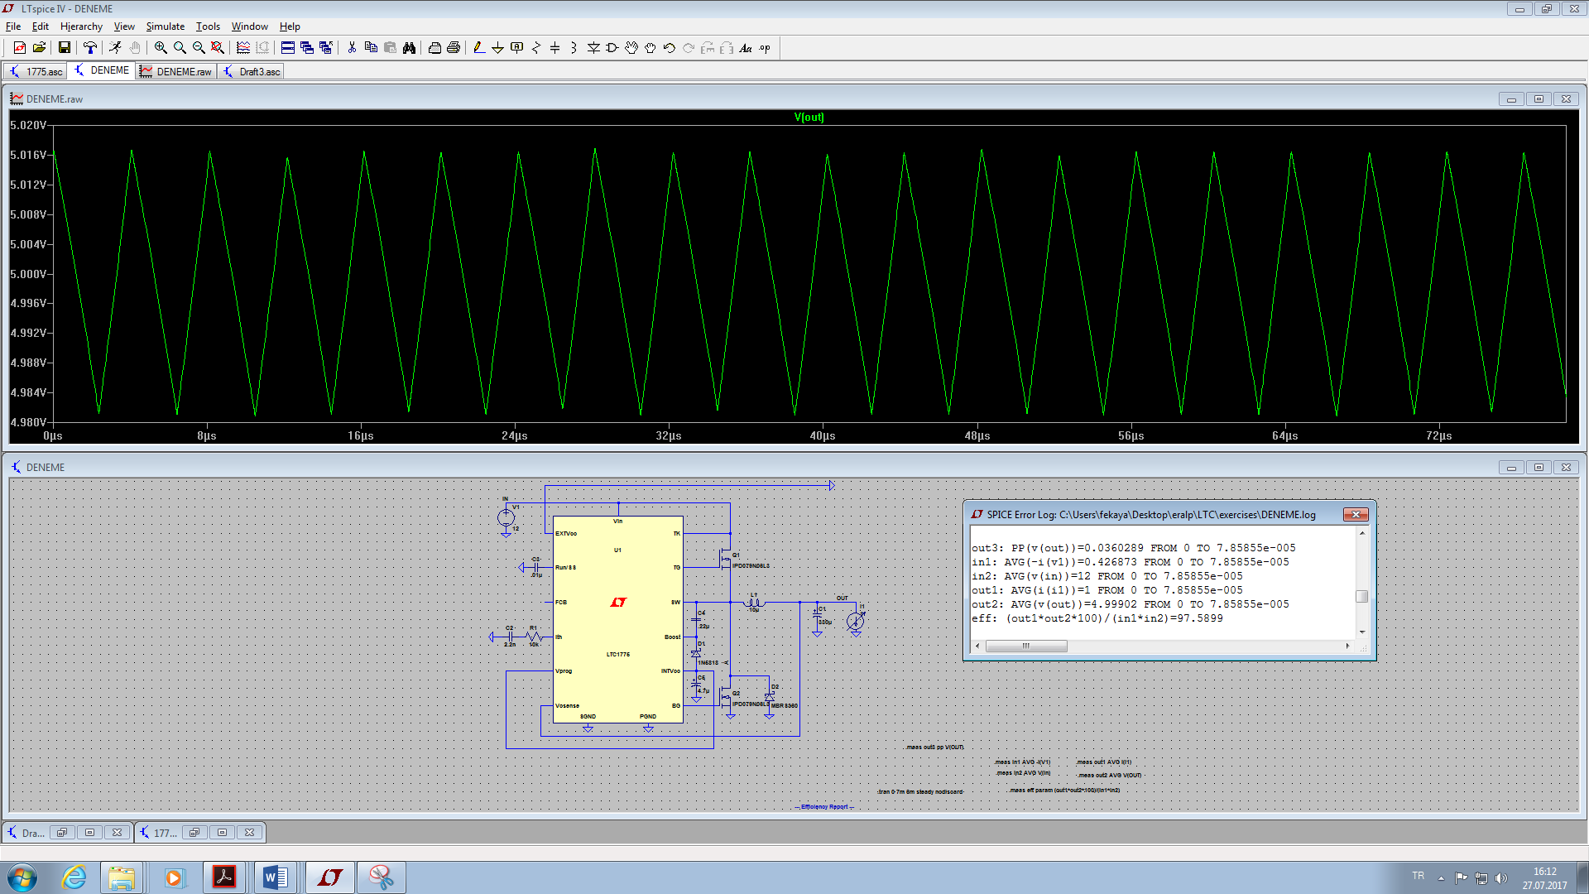

Figure 18. Ripple Voltage Graph for 1A load

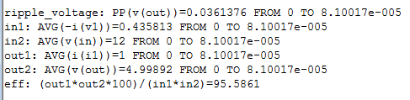

Figure 19. Ripple Voltage, Input Current, Input Voltage, Output Current, Output Voltage and Efficiency Table for 1A Load

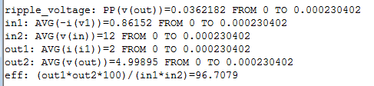

Figure 20. Ripple Voltage, Input Current, Input Voltage, Output Current, Output Voltage and Efficiency Table for 2A Load

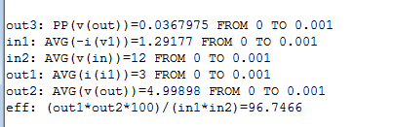

Figure 21. Ripple Voltage, Input Current, Input Voltage, Output Current, Output Voltage and Efficiency Table for 3A Load

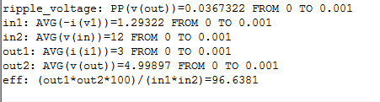

Figure 22. Ripple Voltage, Input Current, Input Voltage, Output Current, Output Voltage and Efficiency Table for 4A Load

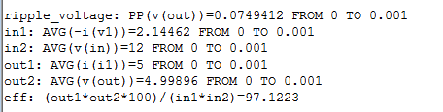

Figure 23. Ripple Voltage, Input Current, Input Voltage, Output Current, Output Voltage and Efficiency Table for 5A Load

In Figure 19, Figure 20, Figure 21, Figure 22, Figure 23;

Ripple voltage: Ripple voltage

in1: Input Current

in2: Input Voltage

out1: Output Voltage

out2: Output Current

eff: Efficiency

1. **Practical Analyses and Tests**

**E.1.) Analysis at 150 kHz Operational Frequency**

**E.1.1.) Efficiency Analysis**

After simulations, I have worked on PCB electronic card. I have done some modifications on the electronic card which is given from ASELSAN to me. Initially, I have used 10uH inductor as my simulation and I connected parallel two 330uH capacitors in order to reduce ESR value and reduce the ripple voltage. Also, I have used STL23NS3LLH7 MOSFET as switching MOSFET. These components have been soldered by me. After that, I have observed efficiencies and ripple voltages by using multimeter and oscilloscope. Firstly, I have observed efficiencies and ripples by arranging load to mA order (Load is arranging to 100mA, 200mA, 300mA, 400mA…). However, there is not stable waveform for low current values. After that I have analyzed efficiencies and ripple voltages for high current loads. I have used BK PRECISION 9130 as power supply, BK PRECISION 8540 as load and Tektronix TDS 380 as oscilloscope during my analysis until now.

$$Efficiency=\frac{Output Voltage*Output Current}{Input Voltage*Input Current}$$

Table 1. Outputs for Varying Load Conditions

|  |  |  |  |  |
| --- | --- | --- | --- | --- |
| Input Voltage (Volts) | Output Voltage (Volts) | Load Value (Amperes) | Efficiency  (%) | Ripple Voltage (mV) |
| 12 | 5.0093 | 1 | 84.0 | 75 |
| 12 | 5.0670 | 2 | 83.6 | 80 |
| 12 | 5.0042 | 3 | 85.8 | 48 |
| 12 | 5.0016 | 4 | 87.0 | 50 |
| 12 | 5.0013 | 5 | 89.2 | 70 |
| 12 | 5.0000 | 6 | 90.3 | 70 |
| 12 | 4.9937 | 7 | 90.5 | 50 |
| 12 | 4.9900 | 8 | 89.7 | 50 |
| 12 | 4.9887 | 9 | 89.0 | 60 |
| 12 | 4.9861 | 10 | 89.0 | 50 |

After calculating Efficiencies, switching MOSFET is changed to CSD18563Q5A and efficiencies are observed again.

When two MOSFETs are compared, efficiency of CSD18563Q5A switching MOSFET is higher than that of STL23NS3LLH7 switching MOSFET. Therefore, CSD18563Q5A has been chosen as switching MOSFET. After determining switching MOSFET, switching ripple has been observed and spectral analysis has been done between 10 kHz-500 kHz interval by using Tektronix DPO 7054 Oscilloscope. Also, load regulation and, line regulation has been calculated which will be mentioned.

Table 2. Efficiency Comparison of Two Type Switching MOSFET’s

|  |  |  |
| --- | --- | --- |
| Load Value (Amperes) | Efficiency When STL23NS3LLH7 switching MOSFET is used (%) | Efficiency When CSD18563Q5A switching MOSFET is used (%) |
| 1 | 84.0 | 84.2 |
| 2 | 83.6 | 89.2 |
| 3 | 85.8 | 93.8 |
| 4 | 87.0 | 93.2 |
| 5 | 89.2 | 92.4 |
| 6 | 90.3 | 92.9 |
| 7 | 90.5 | 92.2 |
| 8 | 89.7 | 88.9 |
| 9 | 89.0 | 87.6 |
| 10 | 89.0 | 87.0 |

**E.1.2.) Ripple Voltage Analysis**

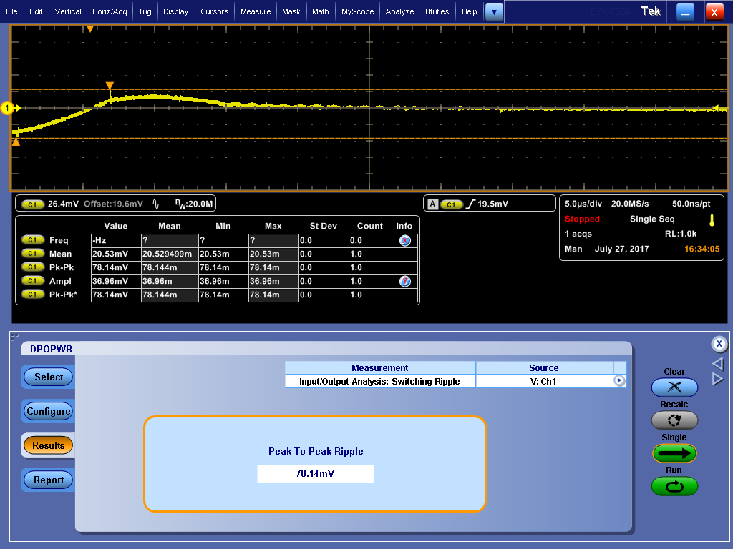

Figure 24. Voltage Ripple with no Load

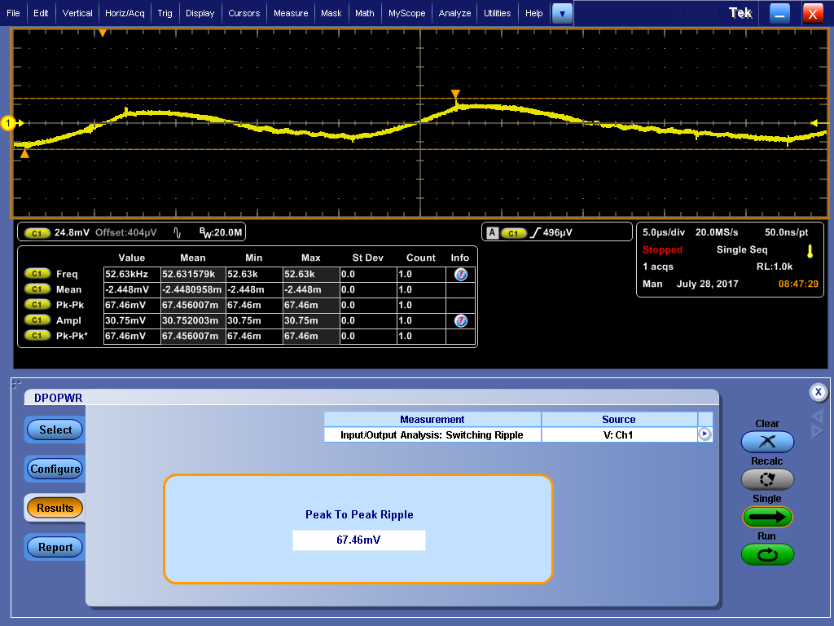

Figure 25. Voltage Ripple with 1A Load

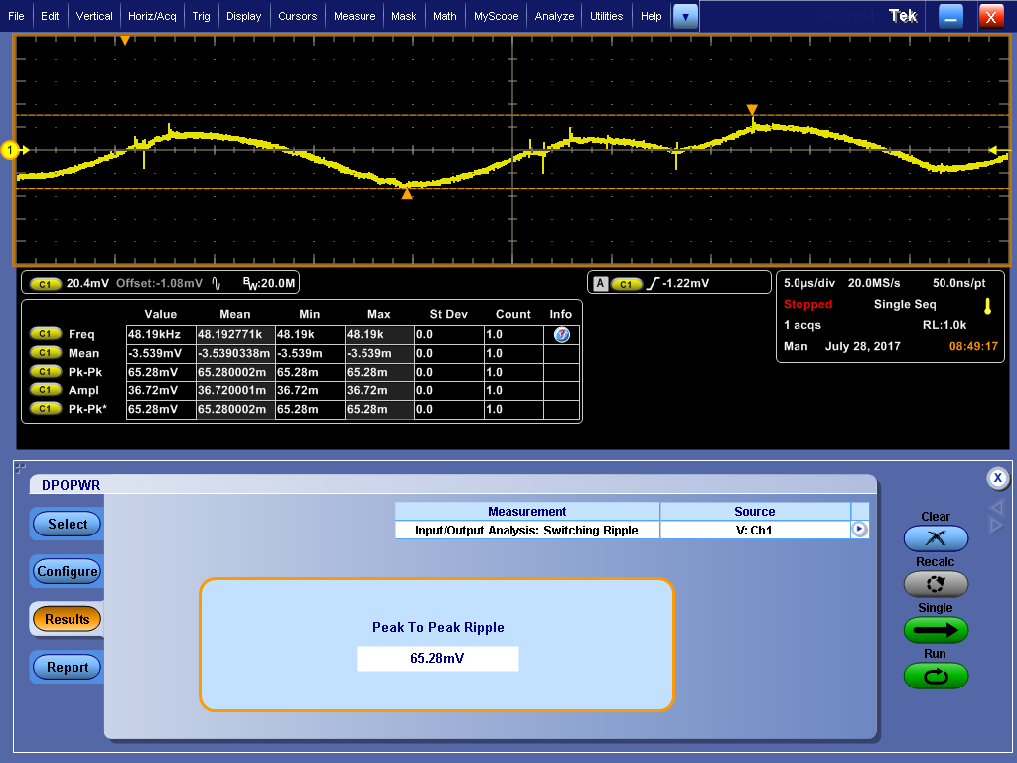

Figure 26. Voltage Ripple with 2A Load

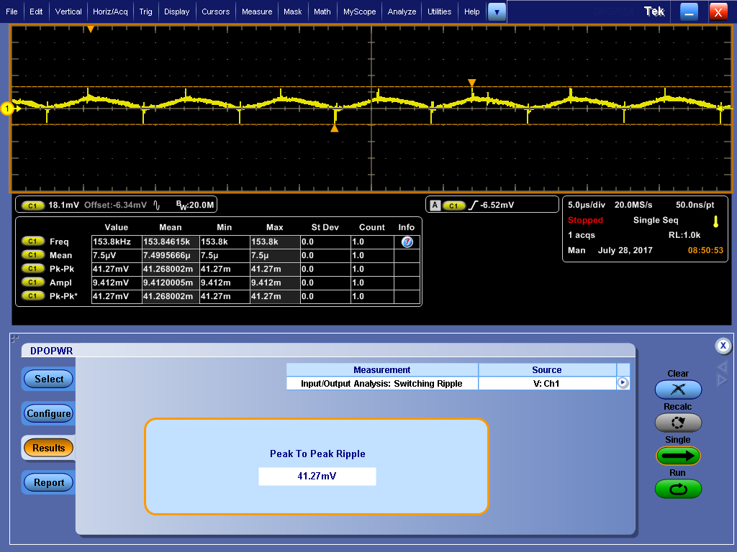

Figure 27. Voltage Ripple with 3A Load

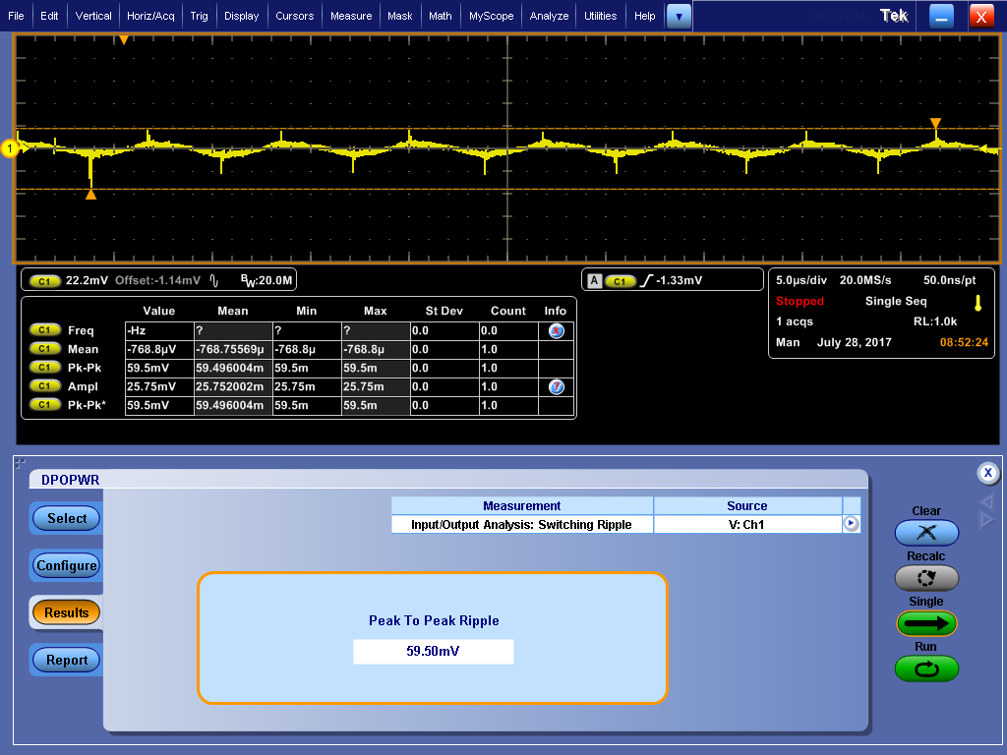

Figure 28. Voltage Ripple with 4A Load

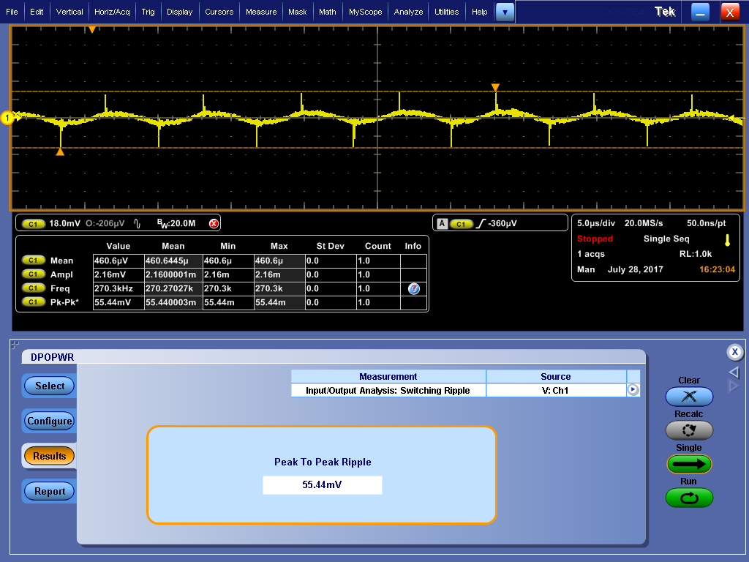

Figure 29. Voltage Ripple with 5A Load

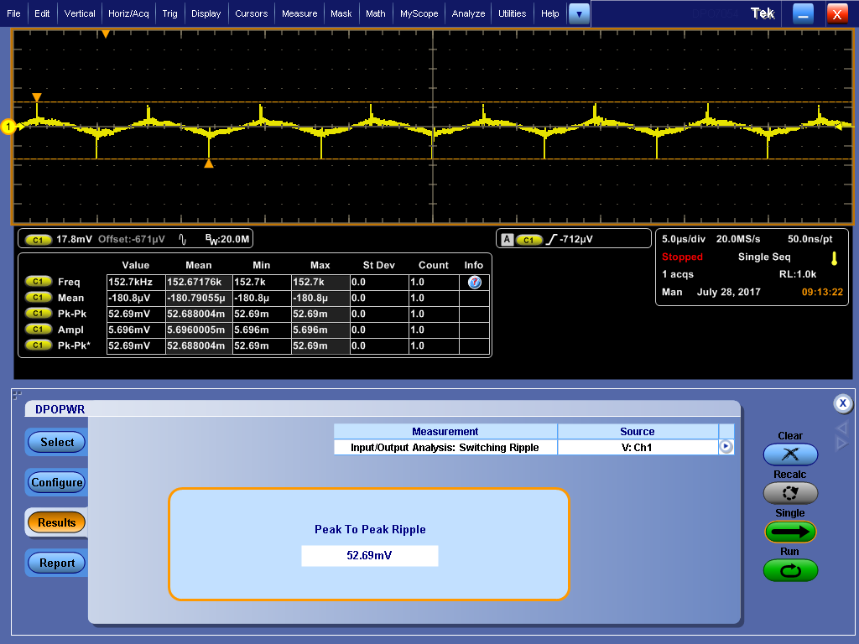

Figure 30. Voltage Ripple with 6A Load

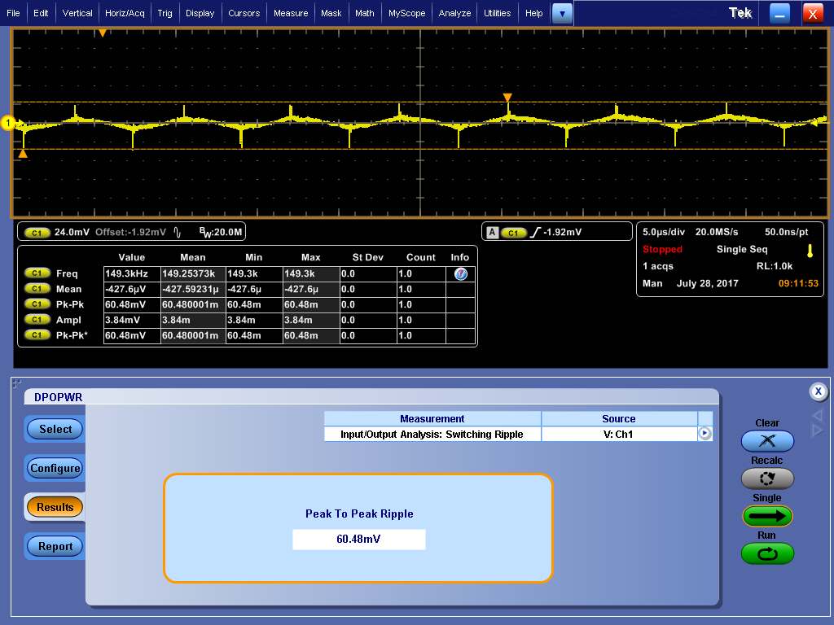

Figure 31. Voltage Ripple with 7A Load

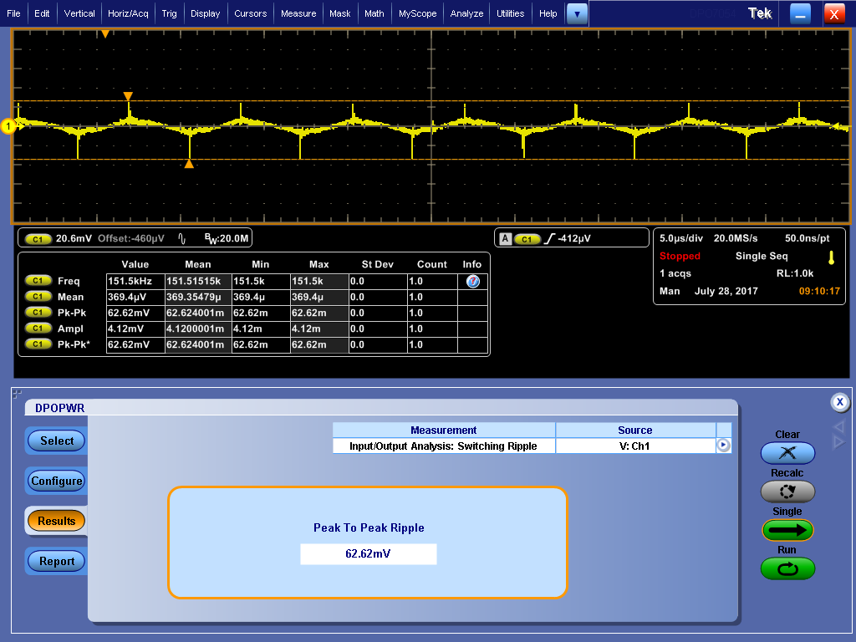

Figure 32. Voltage Ripple with 8A Load

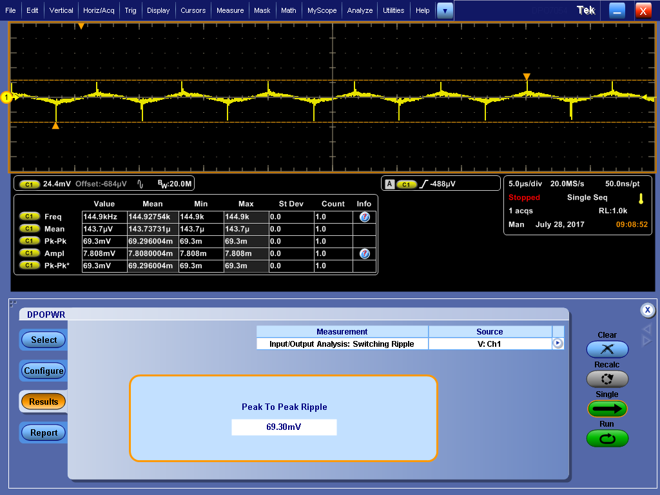

Figure 33. Voltage Ripple with 9A Load

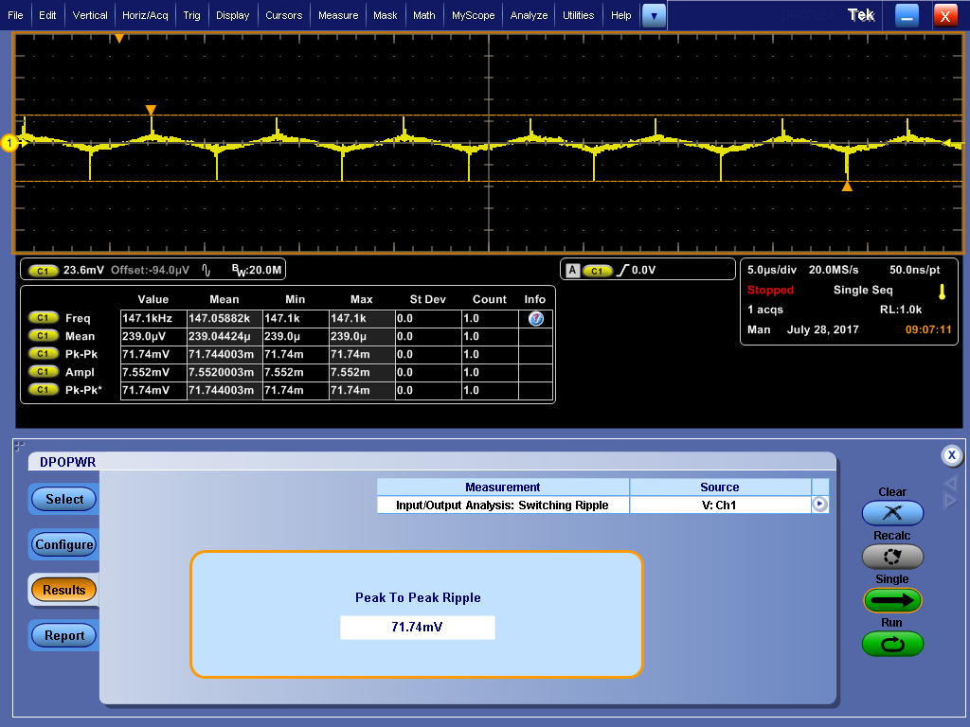

Figure 34. Voltage Ripple with 10A Load

**E.1.3.) Spectral Analysis**

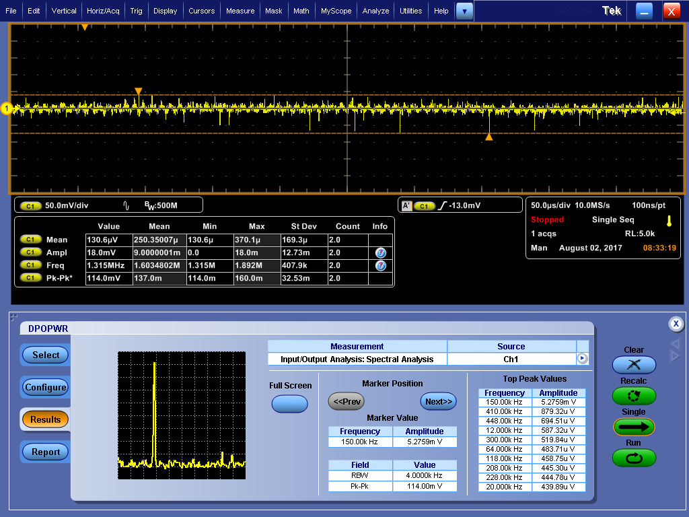

Figure 35. Spectral Analysis at 3A Load

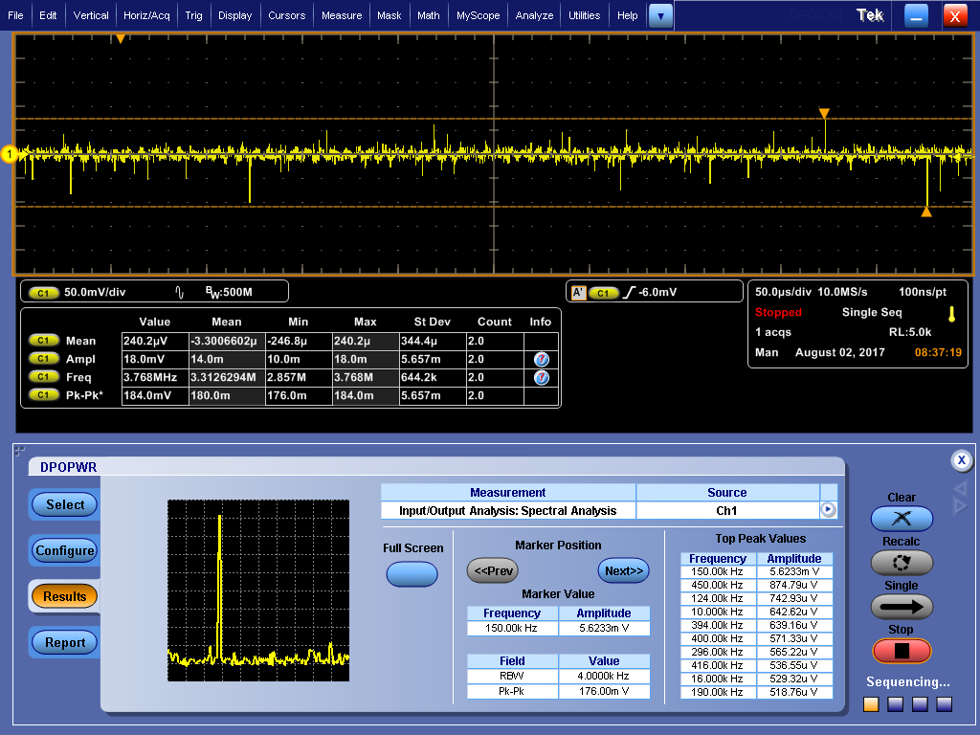

Figure 36. Spectral Analysis at 5A Load

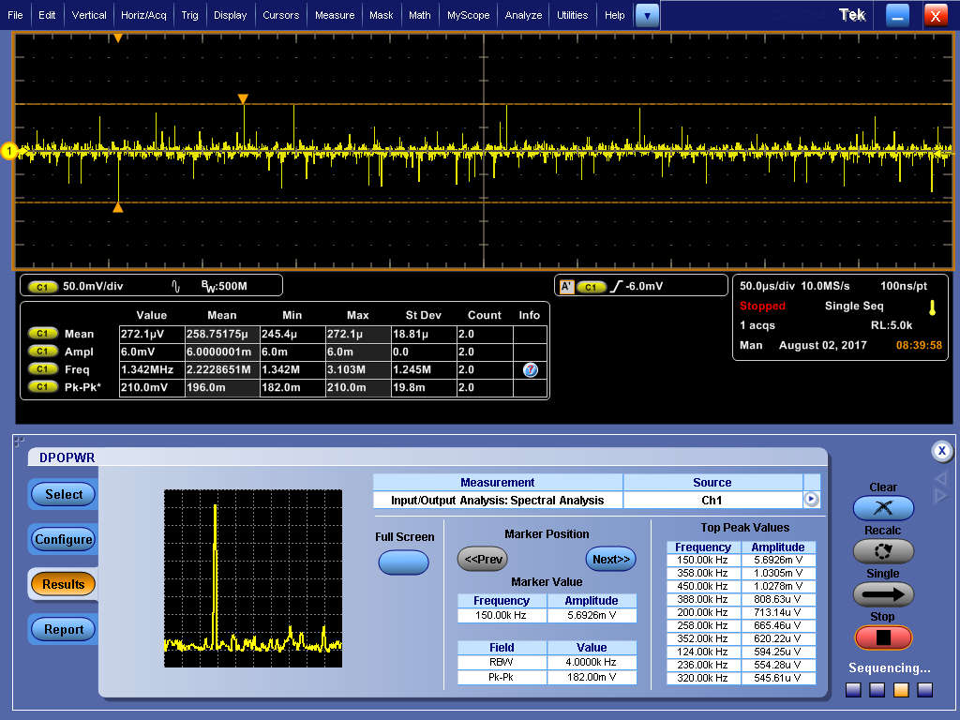

Figure 37. Spectral Analysis at 8A Load

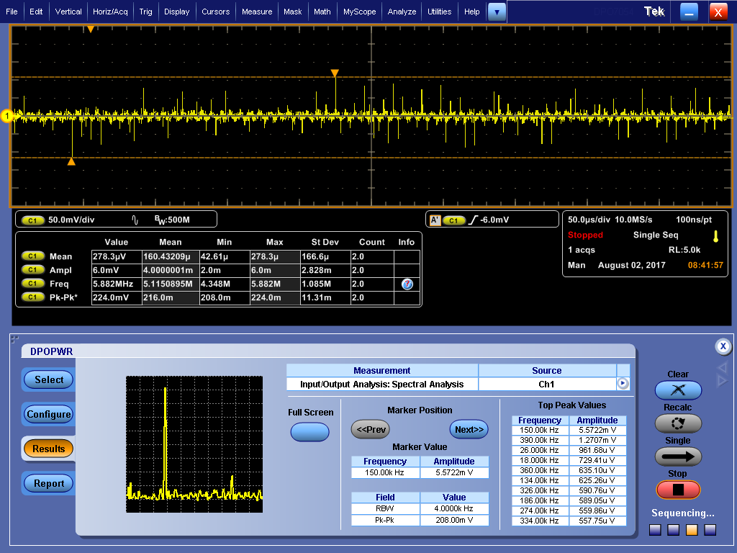

Figure 38. Spectral Analysis at 10A Load

**E.2.) 225 kHz Operational Frequency**

**E.2.1.) Efficiency Analysis**

Operating frequency of Switching MOSFET is 150 kHz because SYNC pin of LTC1775 is grounded. Ripple voltage has maximum value at 150 kHz as expected as shown in spectral analysis tests.

After that SYNC pin and INTVCC pins have been tied so operational frequency has been increased to 225 kHz and ripple and spectral analyses have been repeated. Efficiencies also have been measured at that condition.

Table 3. Efficiency Comparison for Varying Operational Frequencies

|  |  |  |
| --- | --- | --- |
| Load Value (Amperes) | Efficiency at 225 kHz Operational Frequency (%) | Efficiency at 150 kHz operational Frequency (%) |
| 1 | 85.2 | 84.2 |
| 2 | 88.4 | 89.2 |
| 3 | 92.9 | 93.8 |
| 4 | 93.7 | 93.2 |
| 5 | 93.7 | 92.4 |
| 6 | 93.3 | 92.9 |
| 7 | 93.0 | 92.2 |
| 8 | 92.2 | 88.9 |
| 9 | 91.3 | 87.6 |
| 10 | 90.6 | 87.0 |

As shown in Table 3, System works more efficiently at 225 kHz operational frequency. At that frequency, switching ripple and spectral analysis also have been done.

E**.2.2.) Ripple Voltage Analysis**

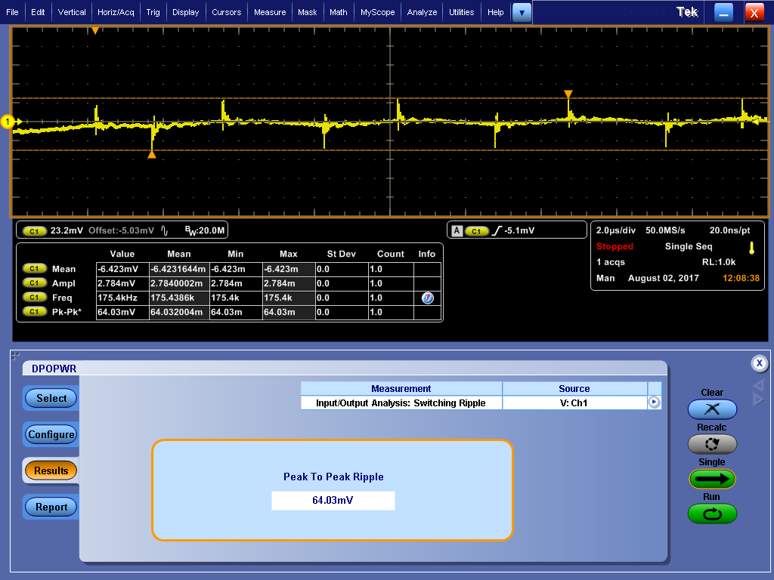

Figure 39. Switching Ripple at 4A Load

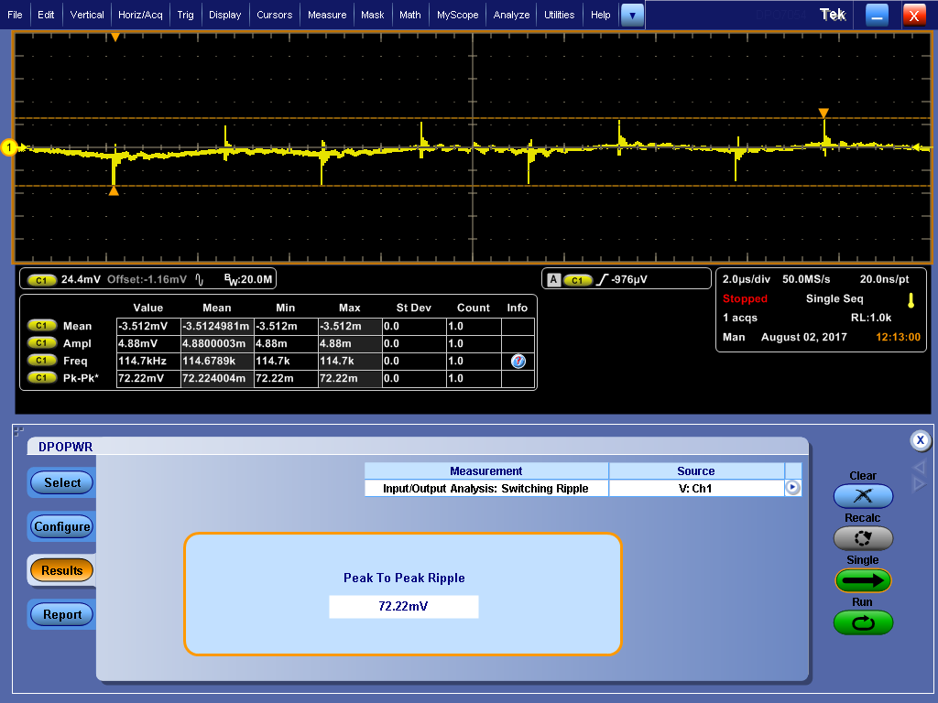

Figure 40. Switching Ripple at 7A Load

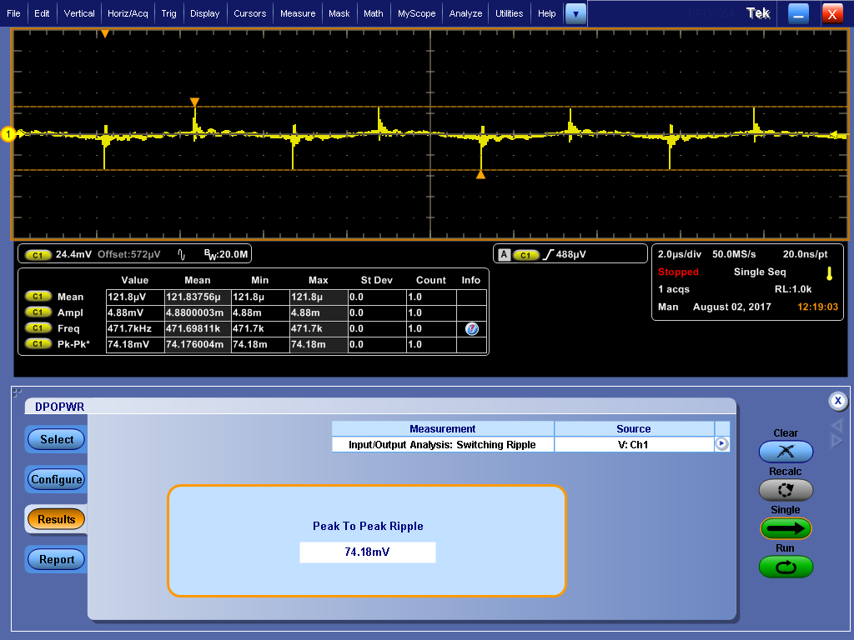

Figure 41. Switching Ripple at 10A Load

Table 4. Switching Ripples for Varying Operational Frequencies

|  |  |  |
| --- | --- | --- |
| Load Value (Amperes) | Switching Ripple at 225 kHz Operational Frequency (mV) | Switching Ripple at 105 kHz Operational Frequency (mV) |
| 1 | 53.10 | 67.46 |
| 2 | 79.33 | 65.28 |
| 3 | 66.60 | 41.27 |
| 4 | 64.03 | 59.50 |
| 5 | 71.14 | 55.44 |
| 6 | 76.75 | 52.69 |
| 7 | 72.22 | 60.48 |
| 8 | 74.40 | 62.62 |
| 9 | 71.40 | 69.30 |
| 10 | 74.18 | 71.74 |

As shown in Table 4, ripple voltages a bit higher at 225 kHz operational frequency because at higher frequency switching loss is high.

**E.2.3.) Spectral Analysis**

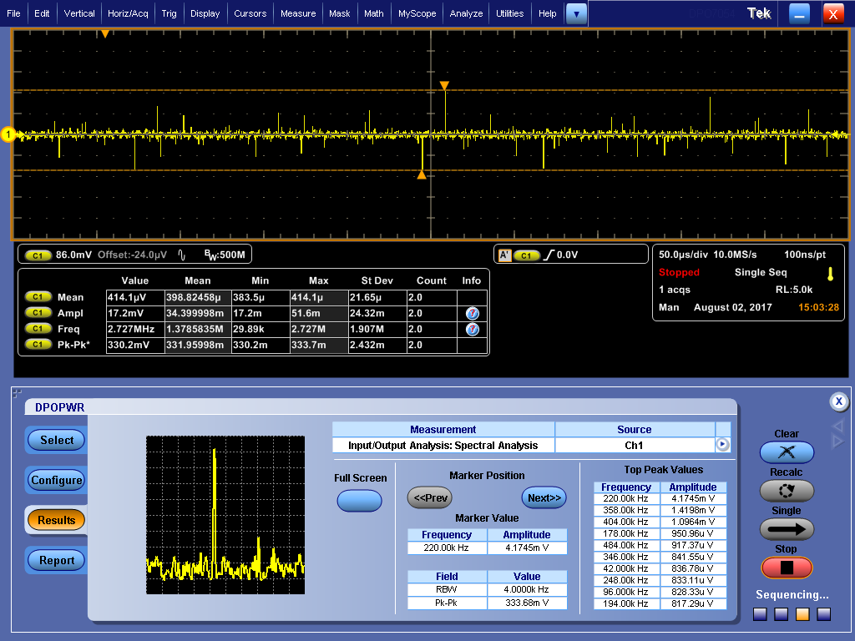

Figure 42. Spectral Analysis at 4A Load at 225 kHz Operational Frequency

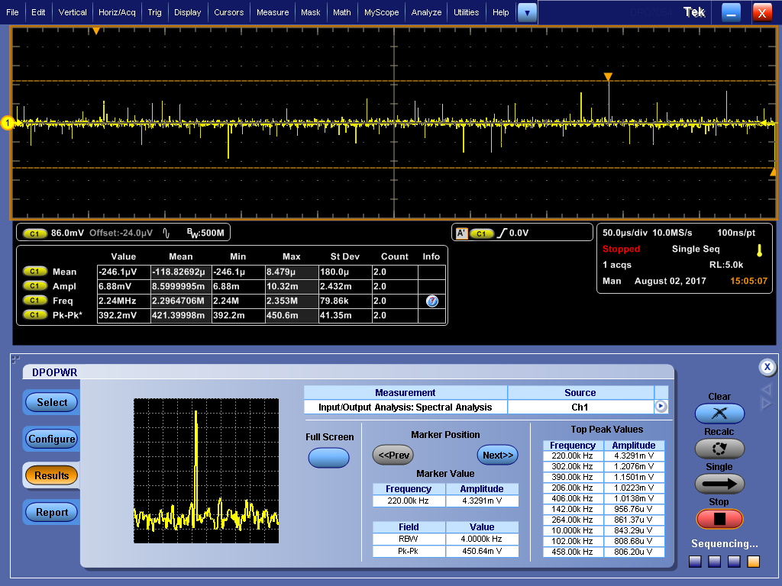

Figure 43. Spectral Analysis at 6A Load at 225 kHz Operational Frequency

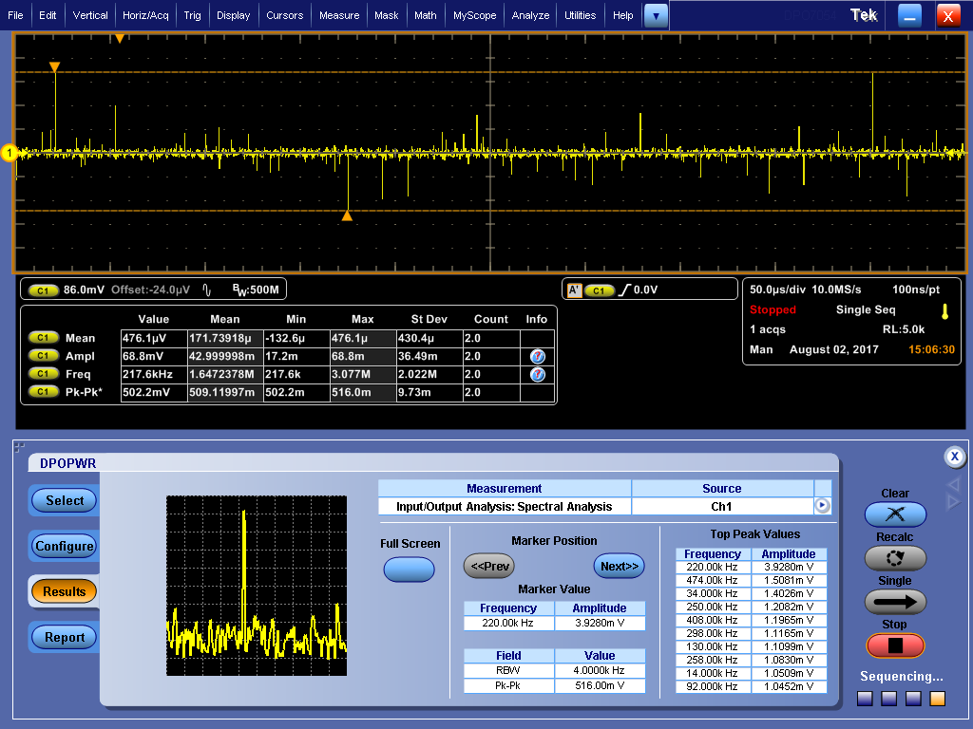

Figure 44. Spectral Analysis at 8A Load at 225 kHz Operational Frequency

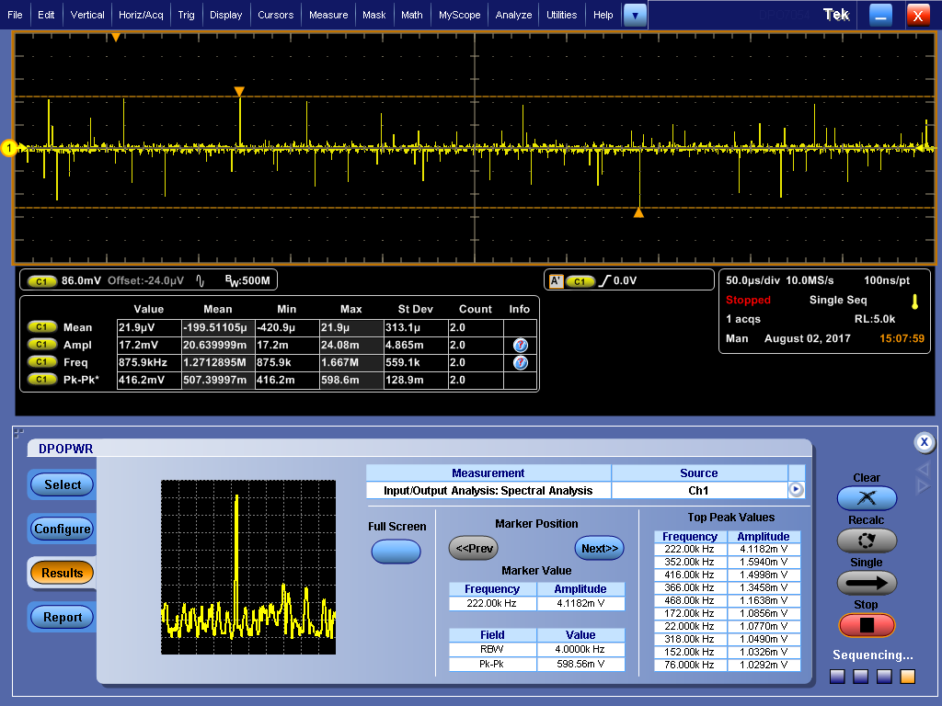

Figure 45. Spectral Analysis at 10A Load at 225 kHz Operational Frequency

Furthermore, voltage characteristics at the instant that load is opened and closed are observed. When the system is loaded with 10 A current, output voltage falls instantly as shown in Figure 46. Moreover, when the load is removed, output voltage rises instantly as shown in Figure 47.

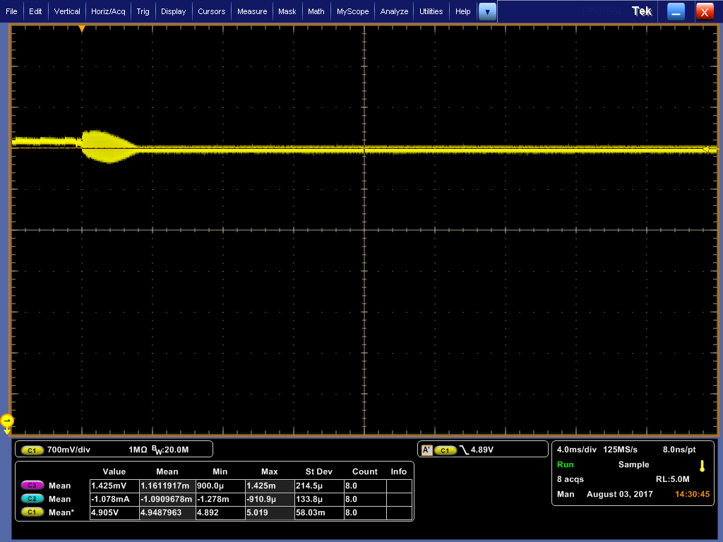

Figure 46. Voltage is Fallen When 10 A Load is Given

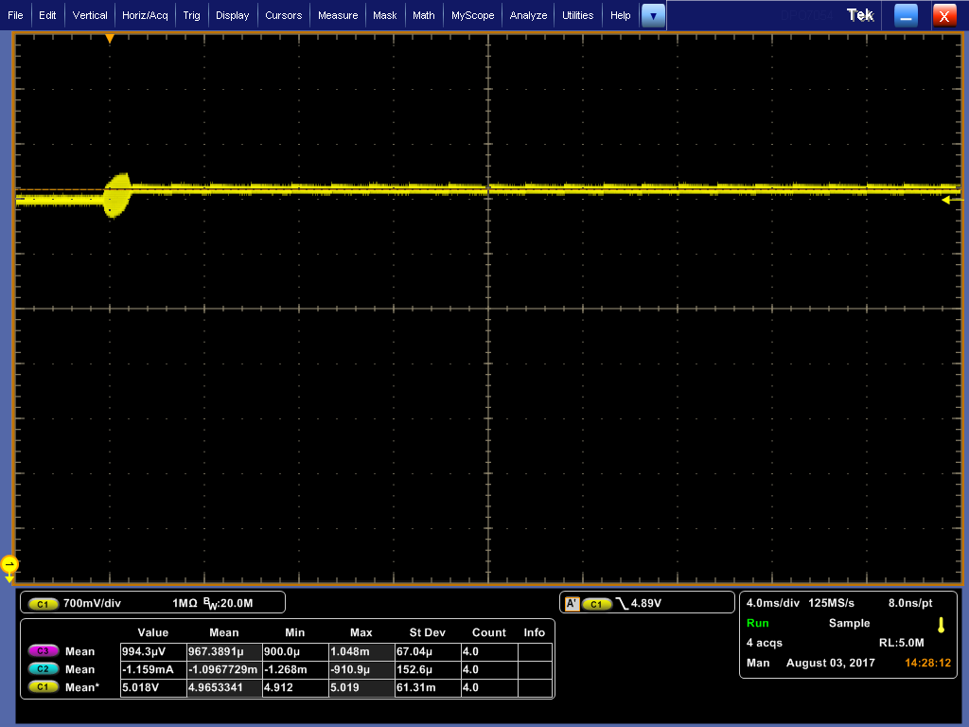

Figure 47. Voltage is Risen When Load is Converted from 10 A to No Load

**E.2.4.) Line and Load Regulations**

In addition, Line regulation and load regulation have been measured at 225 kHz operational frequency.

Line regulation is a measure of the circuit’s ability to maintain the specified output voltage with varying input voltage and Load regulation is a measure of the circuit’s ability to maintain the specified output voltage under varying load conditions [2].

$Line regulation=\frac{Δvout }{ΔVin }$ (5)

Line regulation has been measured for no load, 5A load and 10 A load conditions with 10-14 Volts output interval.

$$Line Regulation with no load=\left|\frac{5.0083-5.0081}{9.987-13.992}\right|*100=0.005\%$$

$$Line Regulation with 5A load=\left|\frac{4.9968-4.9967}{9.927-13.947}\right|*100=0.0025\%$$

$$Line Regulation with 10A load=\left|\frac{4.9838-4.9823}{13.888-9.834}\right|*100=0.037\%$$

$Load Regulation=\frac{\left[\left(Vout with 1A laod\right)-\left(Vout with 9A load\right)\right]}{Vout without load}$ (6)

Load regulation has been measured for 12 V input voltage by using equation (6).

$$load regulation=\frac{5.0083-4.9829}{5.0119}*100=0.51\%$$

**E.3.) Frequency Sweep Analysis When Chroma Varying Load is Used**

After that, Chroma DC Electronic Load 63610-80-20 has been used as a current load. This can give varying currents; that is this load can give 9-11 Amperes interval current instead of constant 10 A current. Varying current is more reliable practically because constant current cannot be obtained every time.

Initially, load current was set 3-5 Amperes interval and it was swept between 10Hz- 50 kHz interval and output voltages were observed.

Table 5. output of Chroma DC Electronic Load

|  |  |  |
| --- | --- | --- |
| Voltage Value (Volts) | Frequency (Hz) | Type |
| 5.0575 | 10 | The highest voltage |
| 4.8076 | 2770 | The lowest voltage |

In addition, when I measure power supply that it gives 4 A current with 2A pick to pick ripple, the highest and the lowest output voltage vary between 4.76 V and 5.05 V at 2770 Hz frequency.

As shown in Table 5, Peak voltage values and corresponding frequencies can be observed by using Chroma DC Electronic load; however, there was not any report on hardware. Therefore, I have found software setup and I have set up software panel. After that sweep analysis results has been obtained second by second.

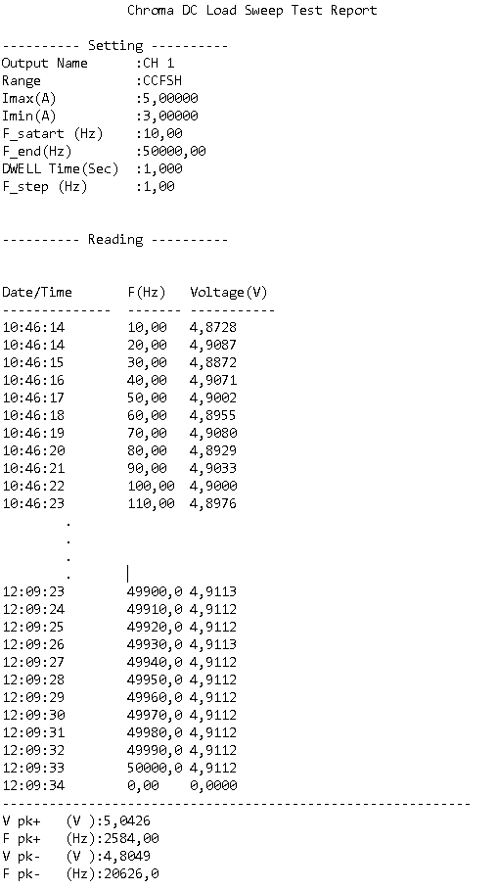

Figure 48. Sweep Analysis for 3-5 A interval

There were 5000 data at sweep analysis so some data were cut in Figure 48.

This .txt file, which is shown in Figure 48, were converted to Excel format and data were analyzed.

Figure 49. Output Voltage Graph of Sweep Analysis

Max voltage= 4.9247 V (at 19656 Hz)

Min voltage= 4.8707 V (at 43212 Hz)

Average voltage = 4.8987 V

There were a discrepancy between Figure 48 and Figure 49 that peak voltages were not coincide with each other. It may cause that pick voltage algorithm of the Chroma DC load is not work properly.

Moreover, overcurrent protection (OCP) test has been done; however, IC1775 did not protected itself because limit current is very high (around 30 A) for IC1775 and these current value was not tried by me because if it was tried, the other components (switching MOSTEF, diodes) can be distorted.

1. **CONCLUSION**

In summary, I have completed my EE400 summer practice in ASELSAN. It was very beneficial for me practically. I had a chance that I can convert my theoretical background to practical work. Also, I have learnt new topologies such as buck converter, boost converter, linear regulators etc. which will help me my academic career. I have used the latest technology oscilloscopes, loads and many other components. Beside technical benefits, I have developed myself in terms of social skills thanks to this summer practice. I have experienced professional work life. In addition, ASELSAN is one of the most important company in Turkey and I had a chance to observe works in ASELSAN which is important to me as a candidate of employee in ASELSAN.

1. **REFERENCES**

[1]M. (2007). Switch Mode Power Supply (SMPS) Topologies [Editorial]. *Microchip,* 2-3.

[2] Linaer Technology. (september 1999). *High Power No RSENSE TM Current Mode Synchronous Step-Down Switching Regulator*[Brochure]. Milpitas: Author.

[3] (1999). *Understanding the Terms and Definitions of LDO Voltage Regulators*(Rep.).

TEXAS INSTRUMENTS

[4] *Synchronous Buck Converter Design Using TPS56xx Controllers in SLVP10x EVMs User’s Guide*(pp. 1-2, Tech.). (1998). Texas Instruments

1. **APPENDIX**
2. <http://cds.linear.com/docs/en/datasheet/1775f.pdf>

**150 kHz**

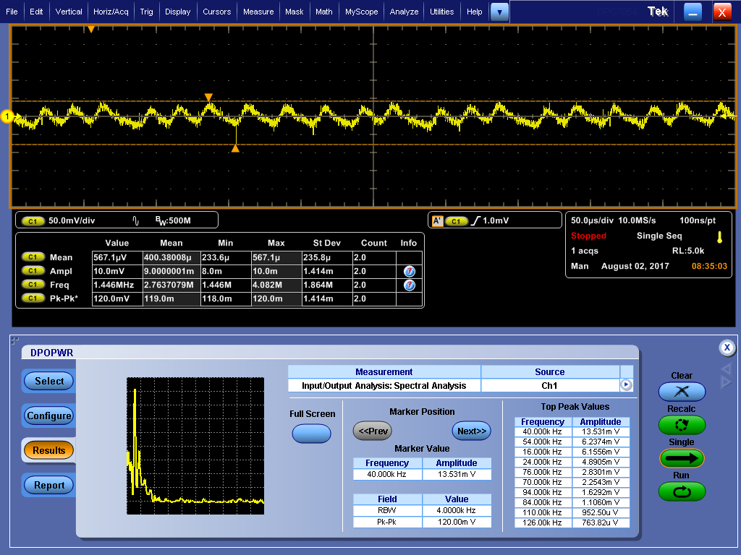

Figure 50. Spectral Analysis at 1A load

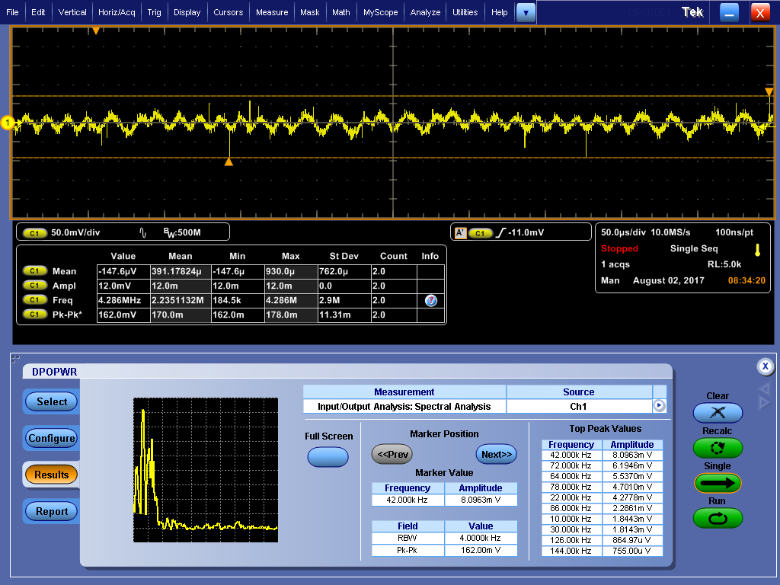

Figure 51. Spectral Analysis at 2A load

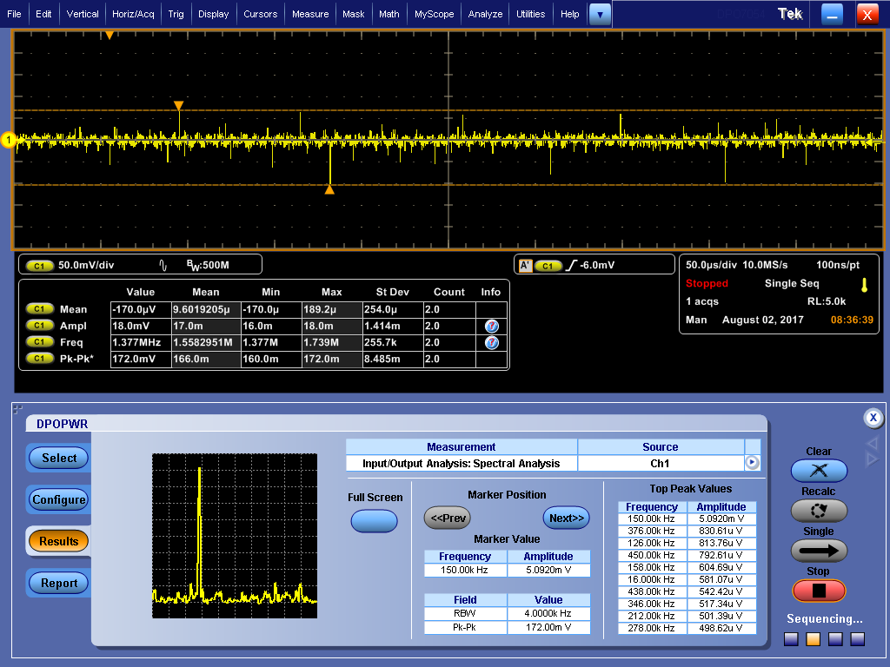

Figure 52. Spectral Analysis at 4A load

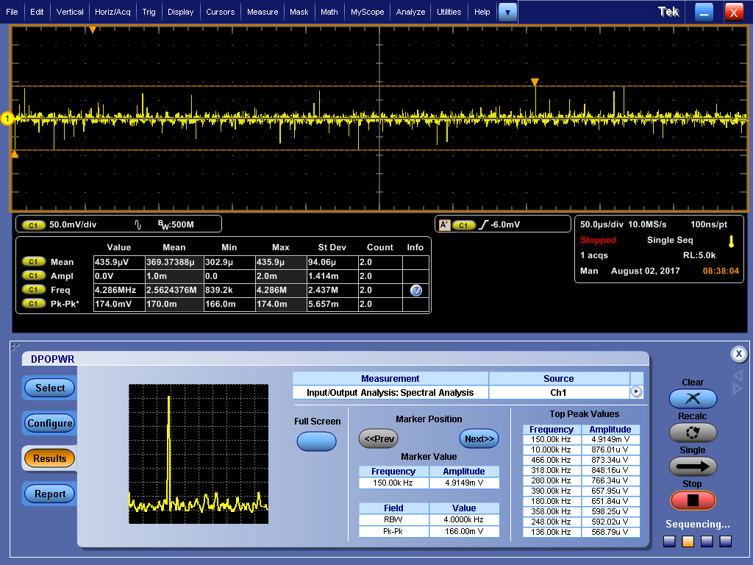

Figure 53. Spectral Analysis at 6A load

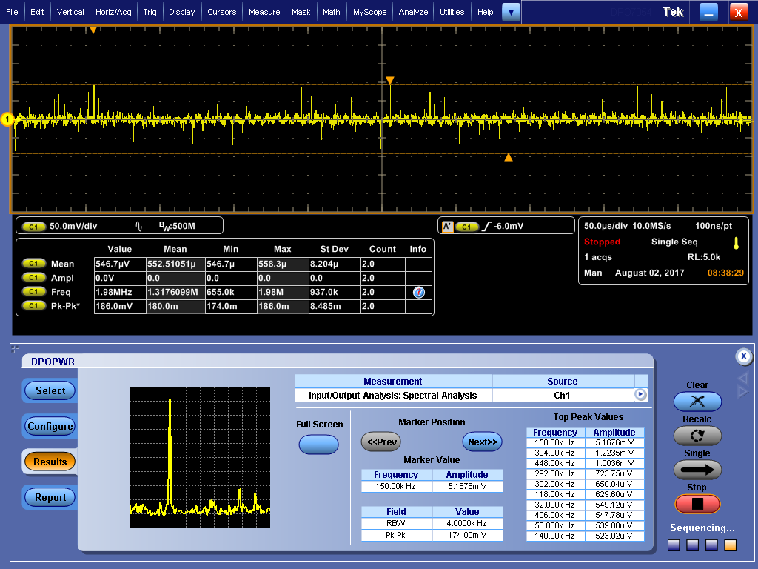

Figure 54. Spectral Analysis at 7A load

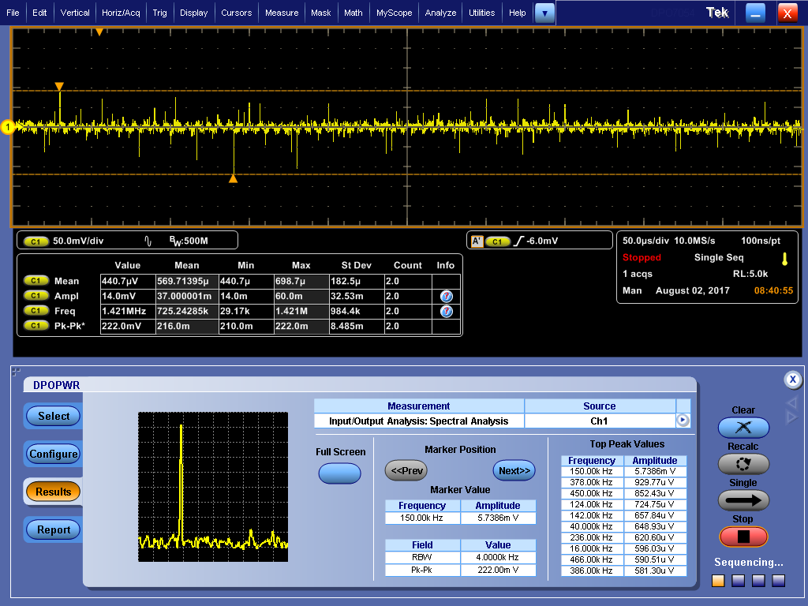

Figure 55. Spectral Analysis at 9A load

**225 kHz**

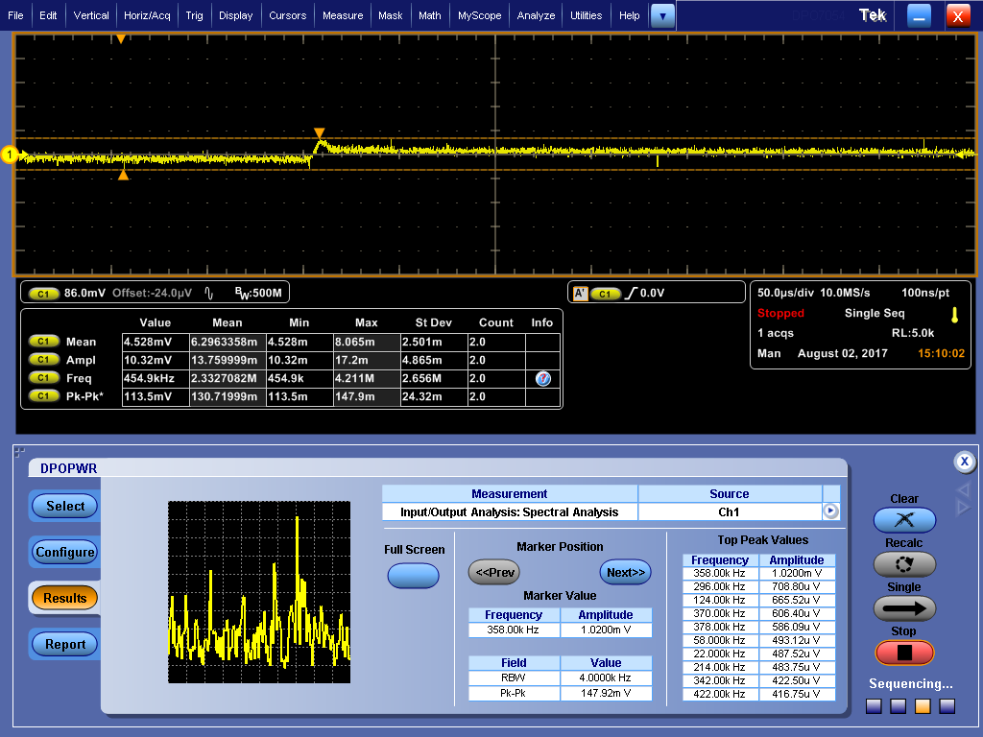

Figure 56. Spectral Analysis without any load

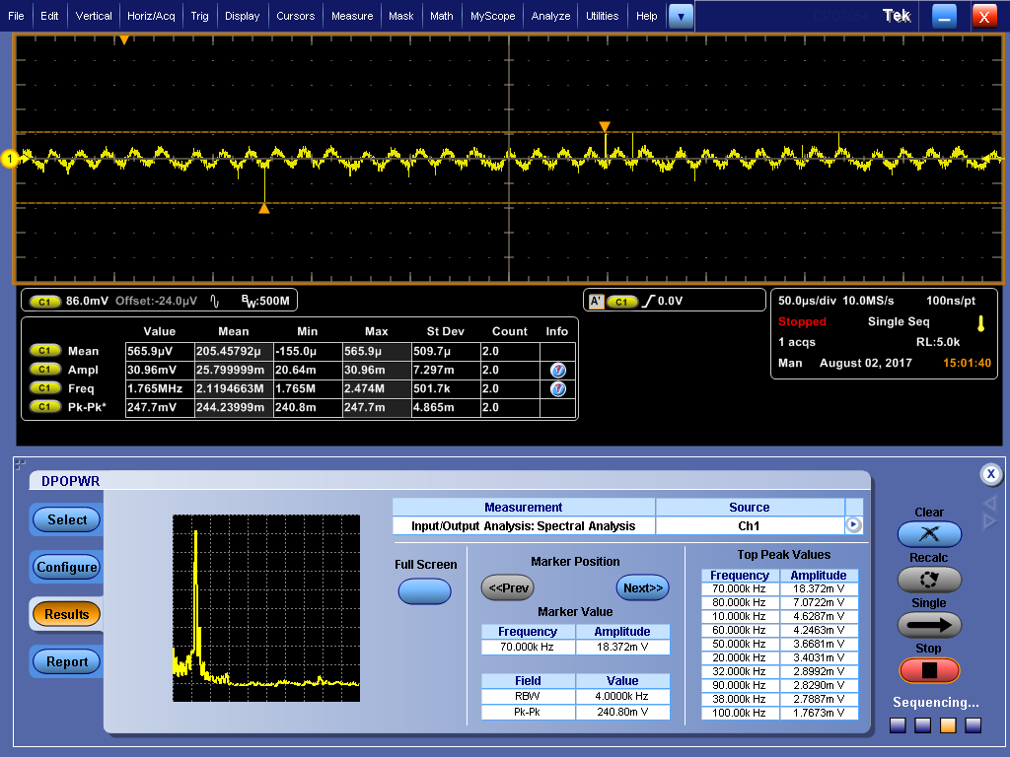

Figure 57. Spectral Analysis with 1A load

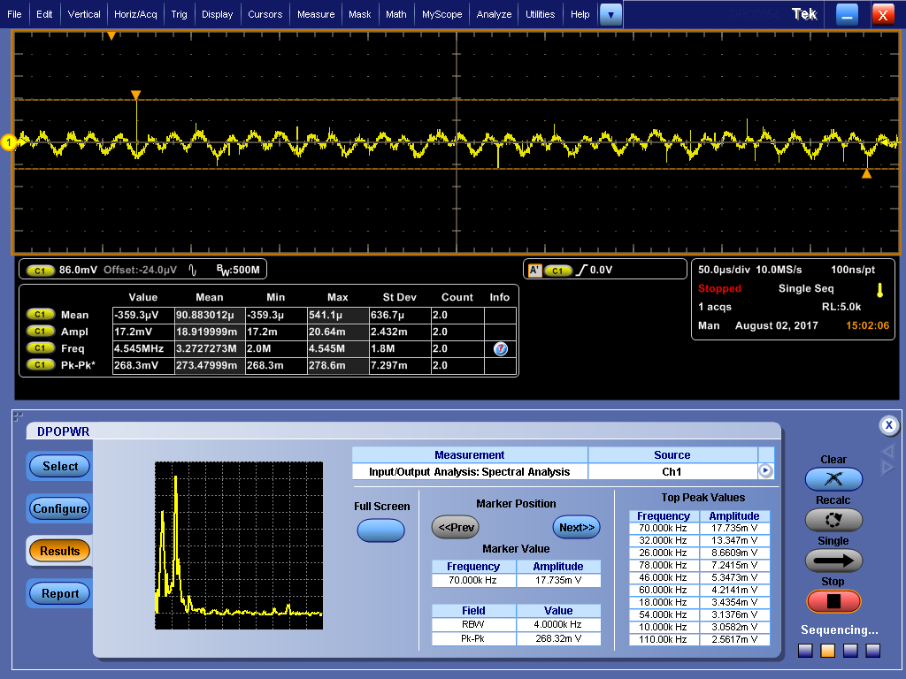

Figure 58. Spectral Analysis with 2A load

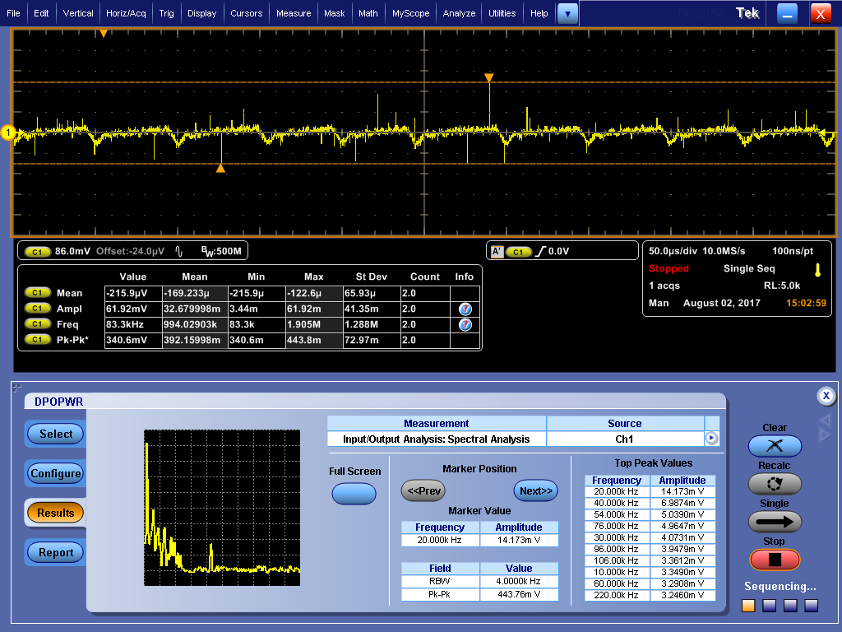

Figure 59. Spectral Analysis with 3A load

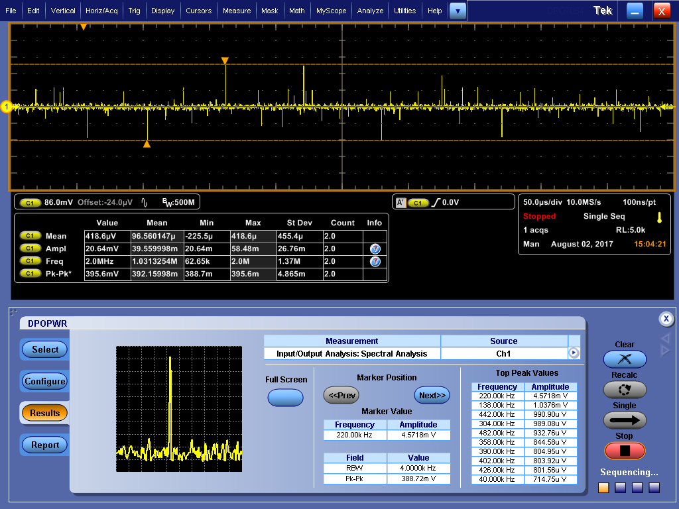

Figure 60. Spectral Analysis with 5A load

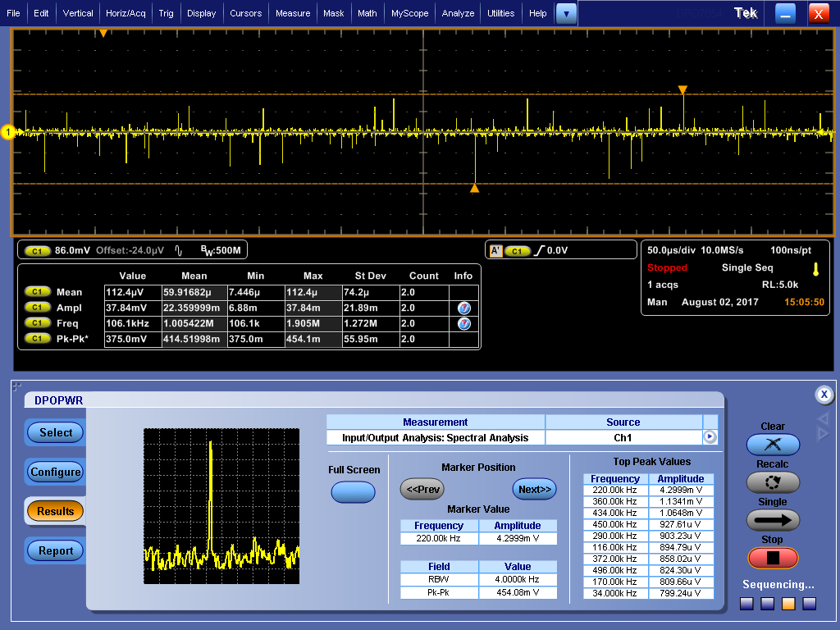

Figure 61. Spectral Analysis with 7A load

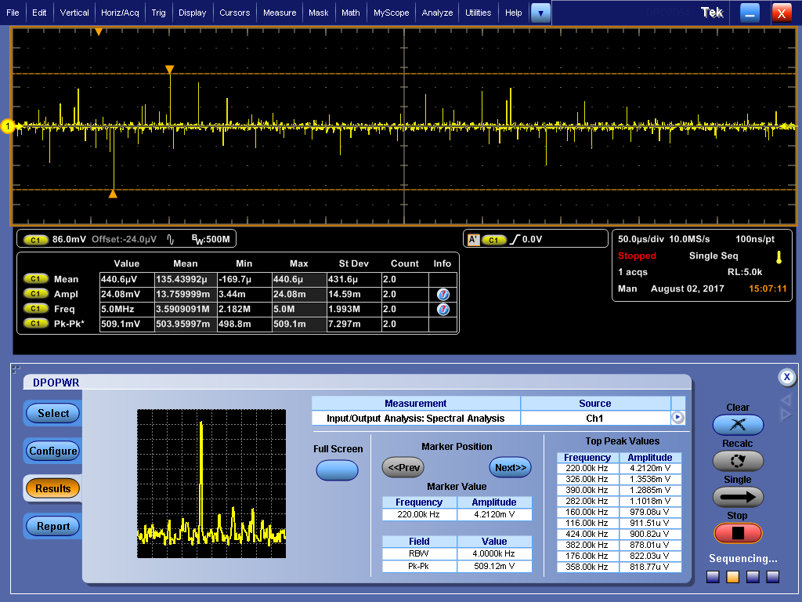

Figure 62. Spectral Analysis with 9A load